Phase 5 part A
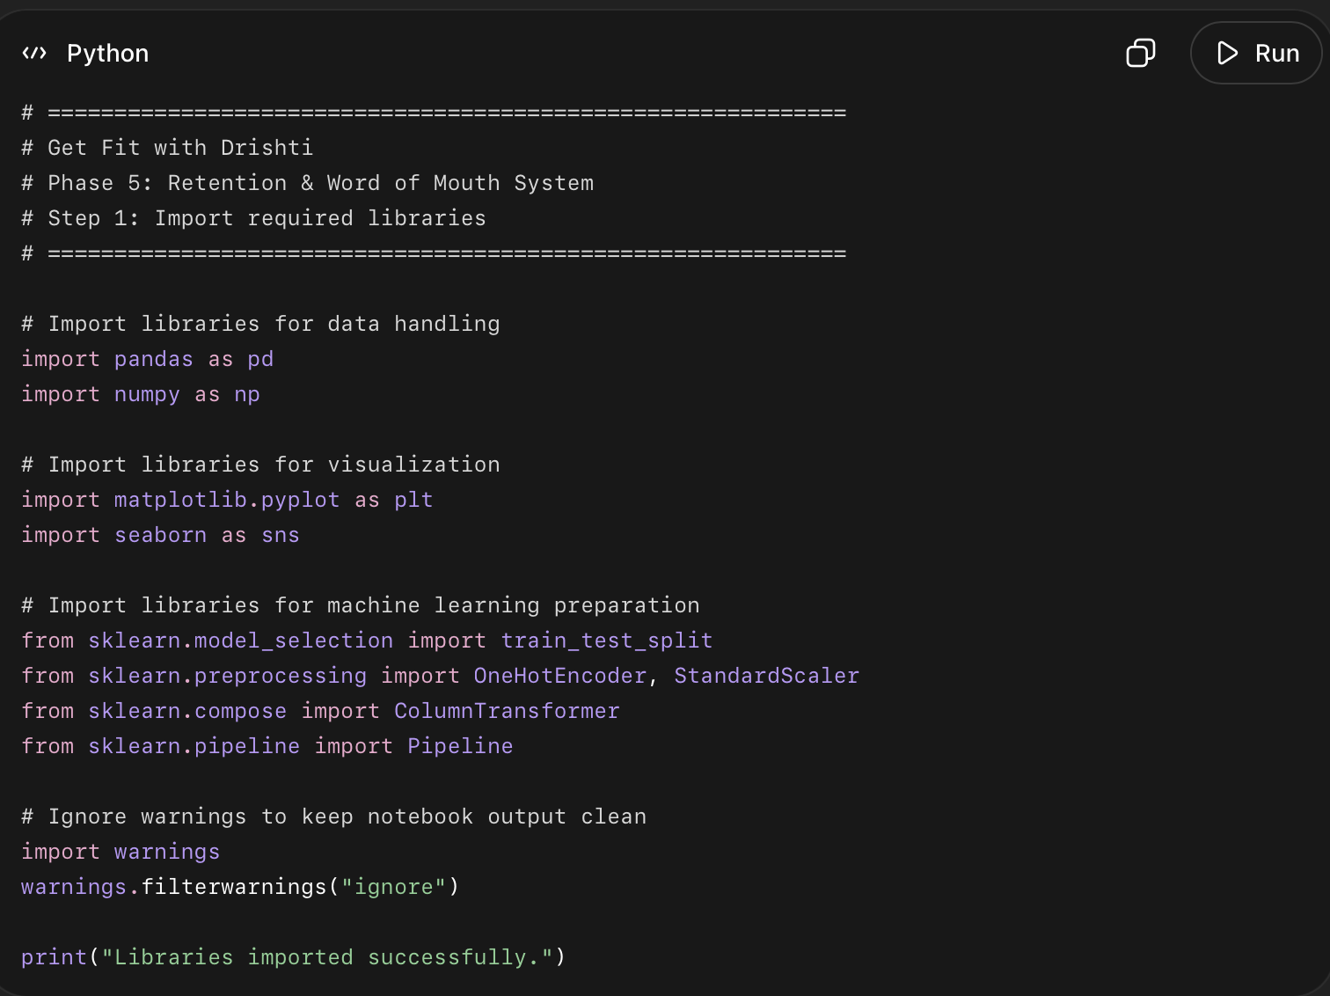
What the code does?
- pandas and numpy → for working with data
- matplotlib and seaborn → for charts
- train_test_split → for splitting data into train and test sets
- OneHotEncoder → for converting text columns into numbers
- StandardScaler → for scaling numeric columns
- ColumnTransformer and Pipeline → for building clean ML workflows

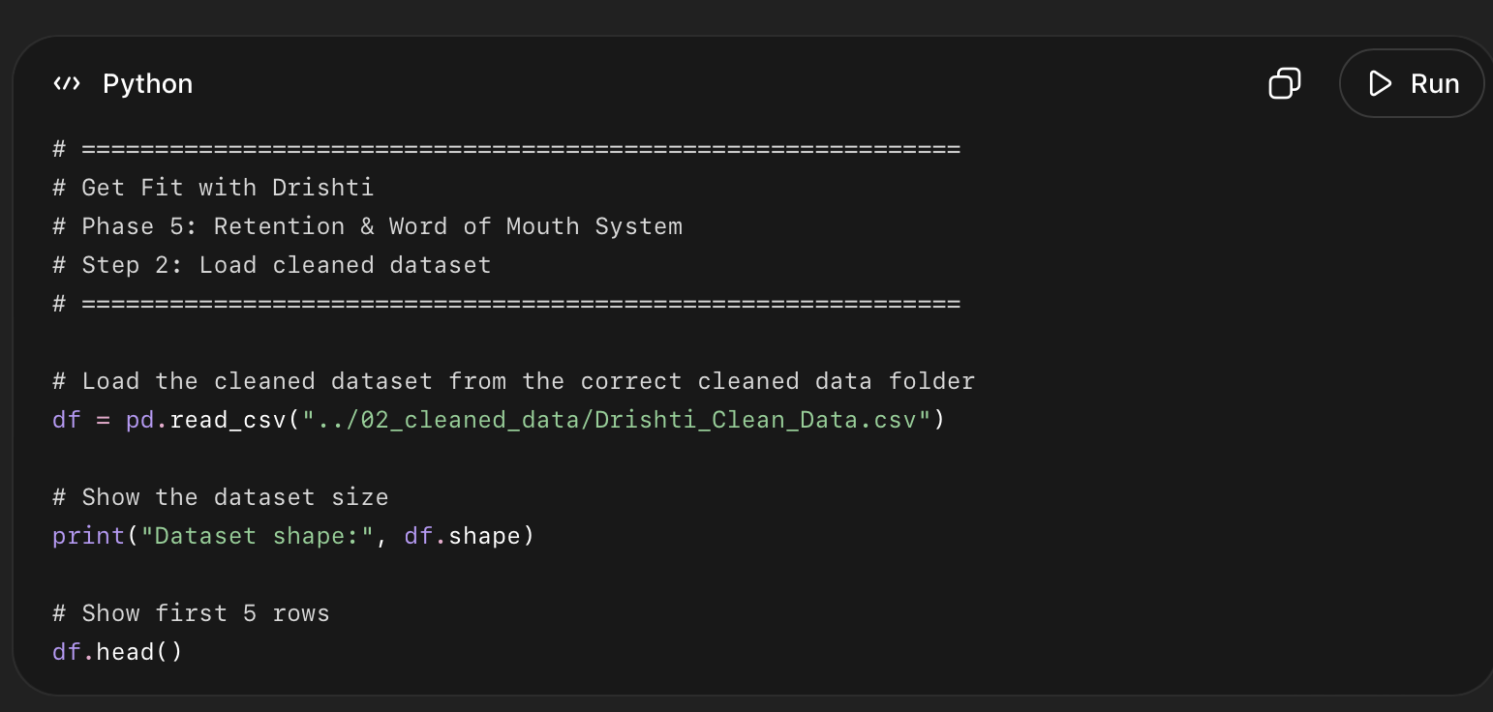
This code does this:
- Loads your cleaned CSV file into Python.
- Saves it inside a dataframe called df.
- Uses the correct folder path:
../02_cleaned_data/Drishti_Clean_Data.csv
- Prints the size of the dataset, like:
Dataset shape: (3000, 40)
- Shows the first 5 rows so you can quickly check if the data loaded correctly.
- Confirms that Phase 5 is using the cleaned dataset, not the raw messy dataset.
Documentation in very simple words:
I loaded the cleaned dataset into the Phase 5 notebook and checked its shape and first few rows to make sure the data was imported correctly before starting the retention and churn analysis.

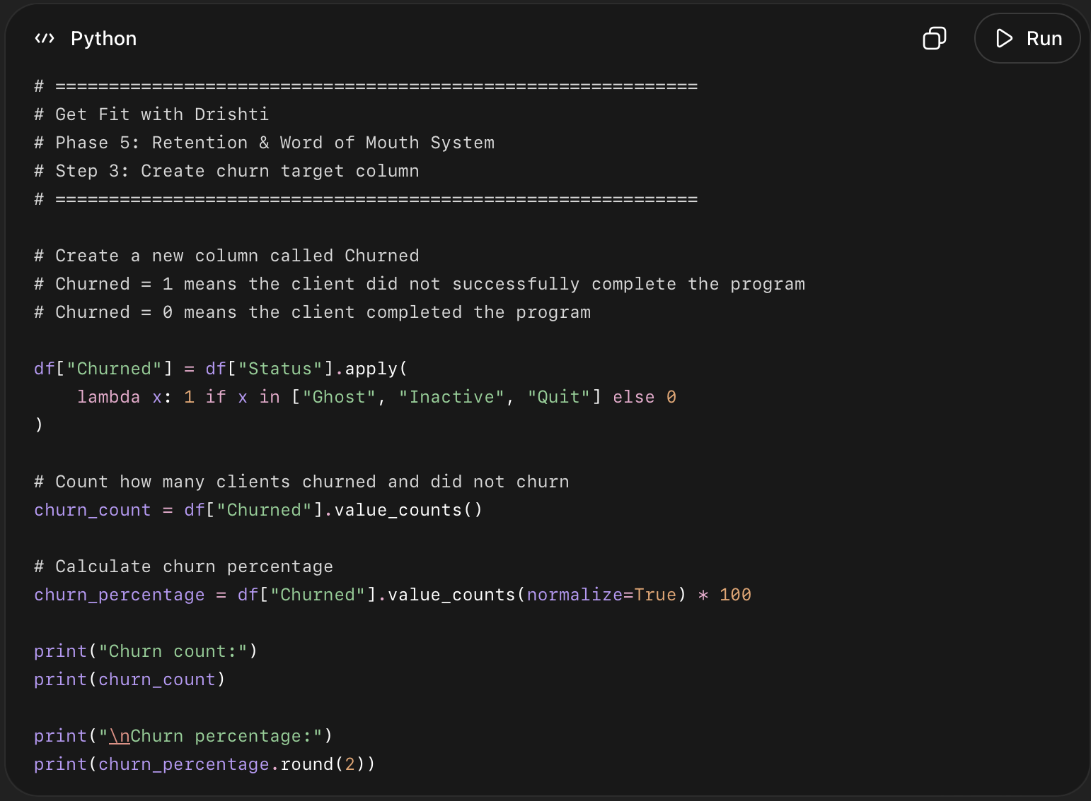

What this code does in easy points
- Creates a new column called Churned.
- Marks clients as 1 if their status is:
  - Ghost
  - Inactive
  - Quit
- Marks clients as 0 if they completed the program.
- Counts how many clients churned vs completed.
- Calculates the churn percentage.
- This gives us the target variable for the churn prediction model.
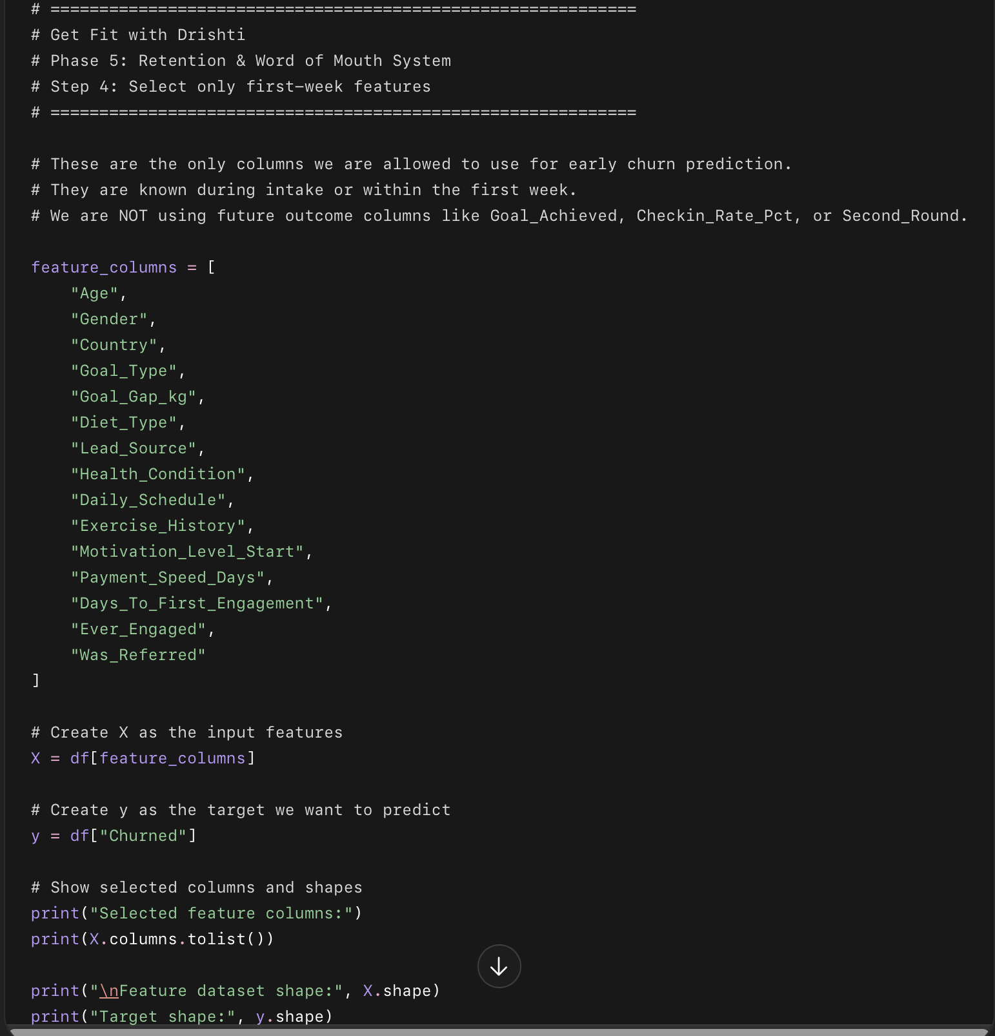

What this code does in easy points
- Creates a list of columns called feature_columns.
- These columns are only the things Drishti knows early:
  - client age
  - goal
  - country
  - diet type
  - lead source
  - motivation level
  - first engagement timing
  - referral status
- Creates X, which contains the input information for the model.
- Creates y, which contains the churn result.
- Checks the size of both X and y.

Why this step matters
This is important because the model should predict churn early, not after the program ends.
So we are avoiding columns like:
Goal_Achieved
Checkin_Rate_Pct
Second_Round
Dropout_Day
Dropout_Reason
Returned_After_Drop
Those are future results. Using them would make the model unrealistic.

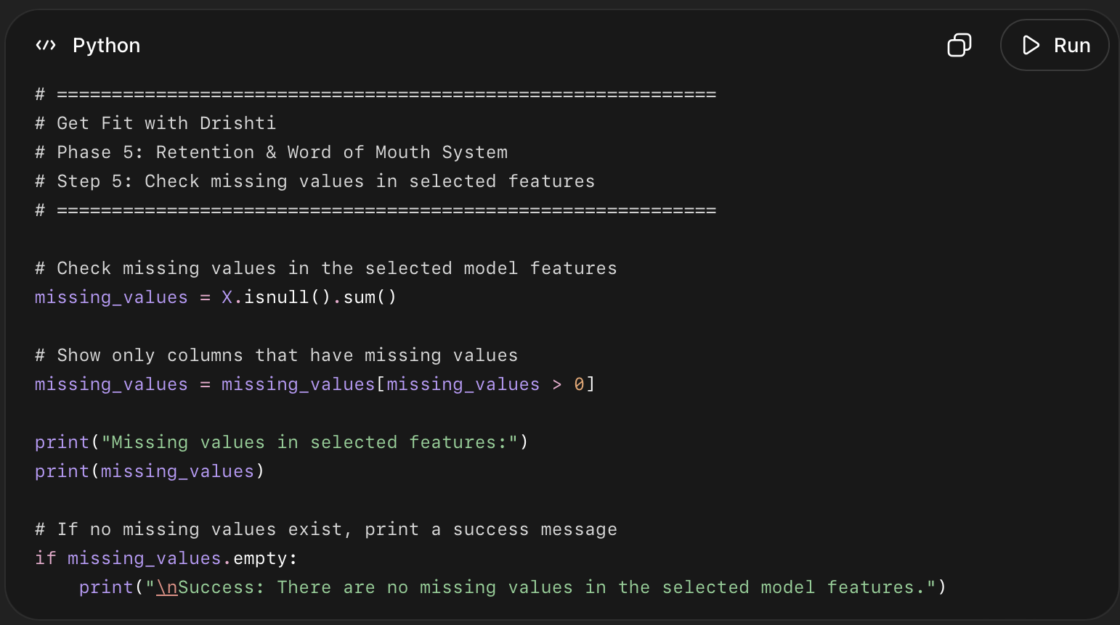

What this code does in easy points
- Checks the 15 selected model columns.
- Counts how many missing values each column has.
- Shows only the columns where missing values exist.
- If nothing is missing, it prints a success message.
- This helps make sure the model will not break later.

Why this step matters
Machine learning models cannot handle missing values unless we fix them first.
Before encoding, scaling, splitting, or training, we need to confirm the selected features are clean.
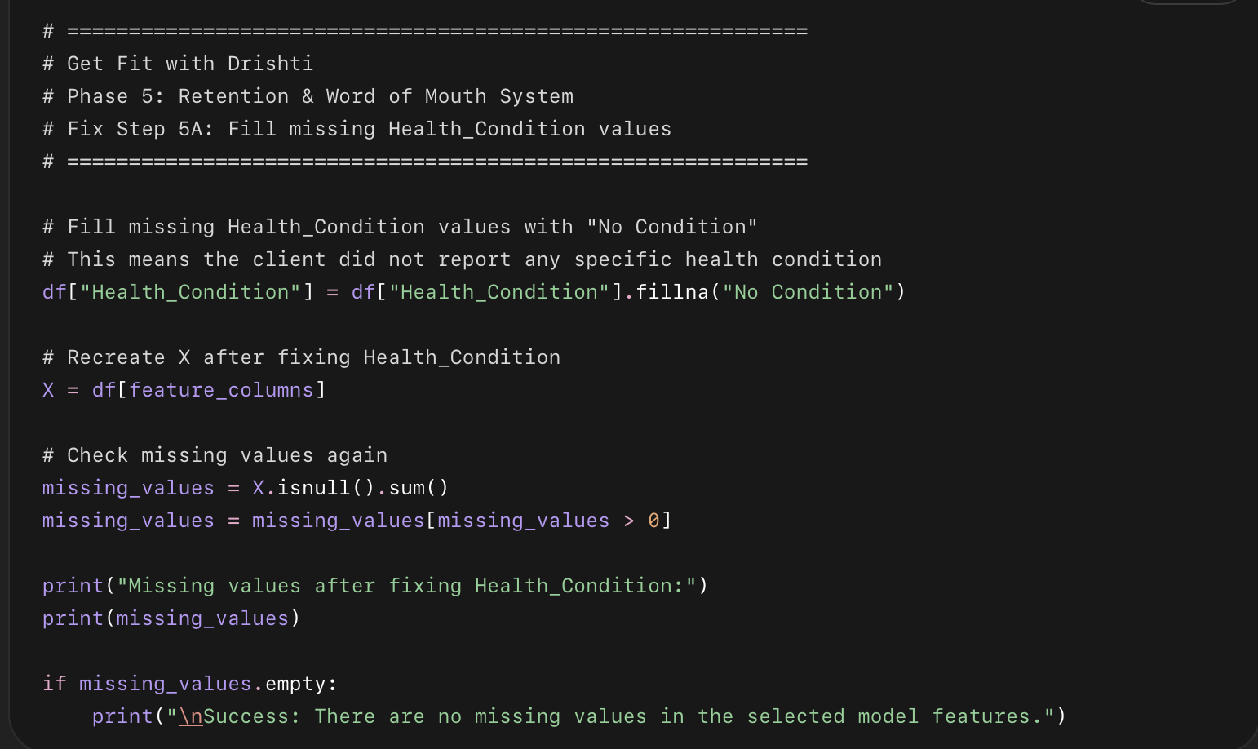

What this code does in easy points
- Finds blank values in Health_Condition.
- Replaces them with "No Condition".
- Recreates X so the model uses the corrected column.
- Checks missing values again.
- Confirms whether all selected model features are now clean.
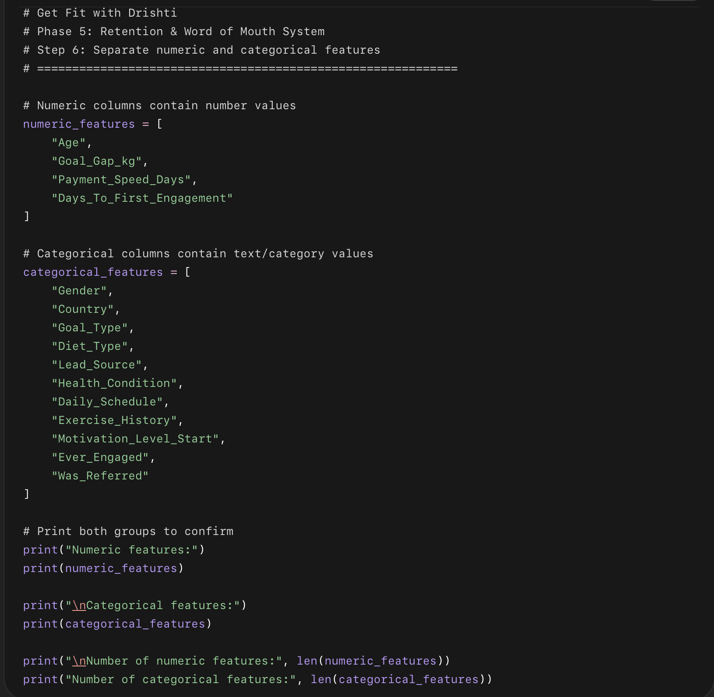

What this code does in easy points
- Splits the 15 model columns into two groups.
- Numeric features are columns with numbers.
- Categorical features are columns with text labels.
- This is needed because numeric and text columns must be processed differently.
- Numeric columns will be scaled later.
- Categorical columns will be encoded later.

Why this step matters
Machine learning models need all inputs to be numeric.
So before training the model:
Age, Goal_Gap_kg, Payment_Speed_Days
can stay as numbers, but columns like:
Gender, Country, Goal_Type, Lead_Source
must be converted into numeric format.

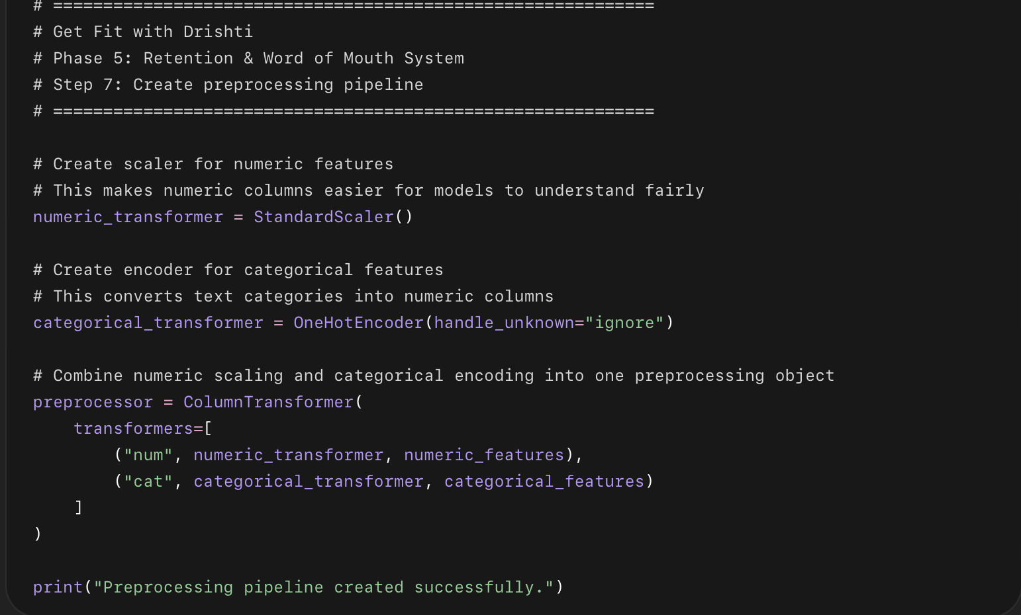

What this code does in easy points
- Creates a scaler for numeric columns.
- Creates an encoder for text/category columns.
- Combines both into one preprocessing object called preprocessor.
- Numeric columns will be scaled.
- Categorical columns will be converted into model-readable numbers.
- handle_unknown="ignore" prevents errors if future clients have a new category the model has not seen before.

Why this step matters
The model cannot directly understand text like:
Female
Nepal
Weight Loss
TikTok
High
So this preprocessing pipeline converts the dataset into a proper machine learning format.

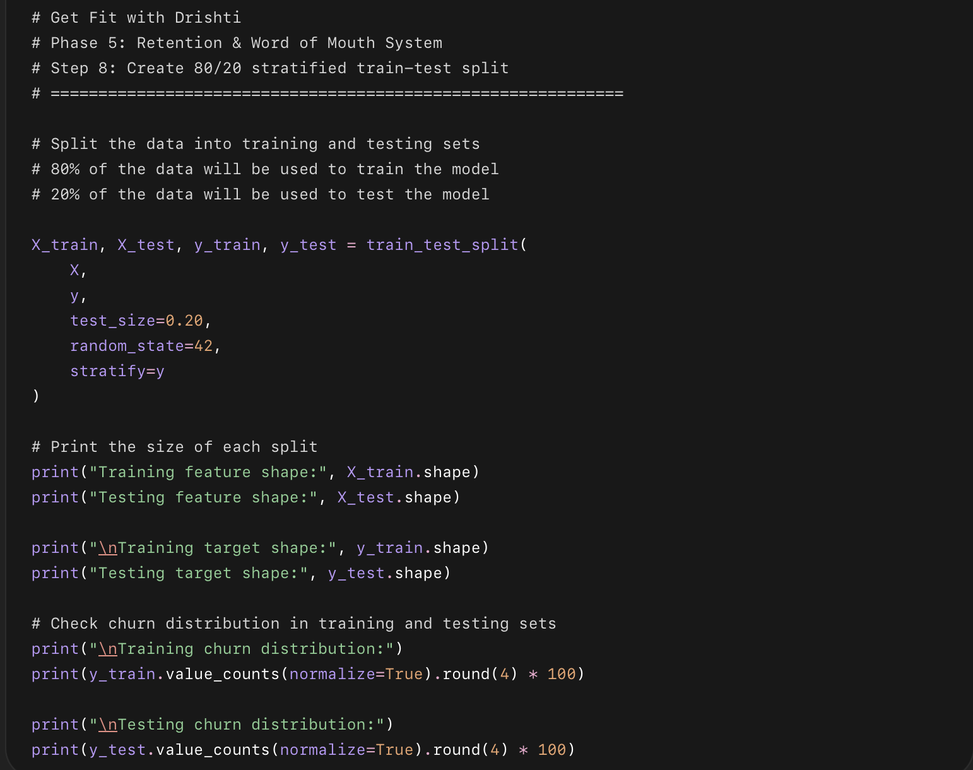

What this code does in easy points
- Splits the data into training and testing parts.
- Uses 80% of clients to train the model.
- Uses 20% of clients to test the model.
- Keeps the churn percentage almost the same in both groups.
- This is important because churned clients are fewer than completed clients.
- Saves the split data into:
  - X_train
  - X_test
  - y_train
  - y_test

Why stratified split matters
Your full dataset has around:
81% completed clients
19% churned clients
Using stratify=y makes sure both train and test sets keep almost the same ratio.
Without stratification, the test set could accidentally have too many or too few churned clients, which would make model evaluation unfair.

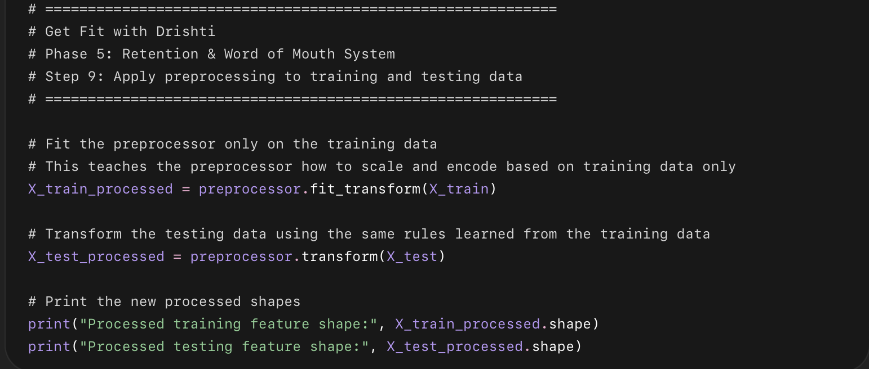

What this code does in easy points
- Applies the preprocessing pipeline we created earlier.
- Scales the numeric columns.
- Converts categorical text columns into numeric columns.
- Fits the preprocessing only on training data.
- Applies the same preprocessing rules to testing data.
- Creates two new processed datasets:
  - X_train_processed
  - X_test_processed

Why this step matters
We fit the preprocessor only on X_train, not the full dataset.
That prevents data leakage.
Data leakage means the model accidentally learns information from the test data before testing. That would make the model look better than it really is.

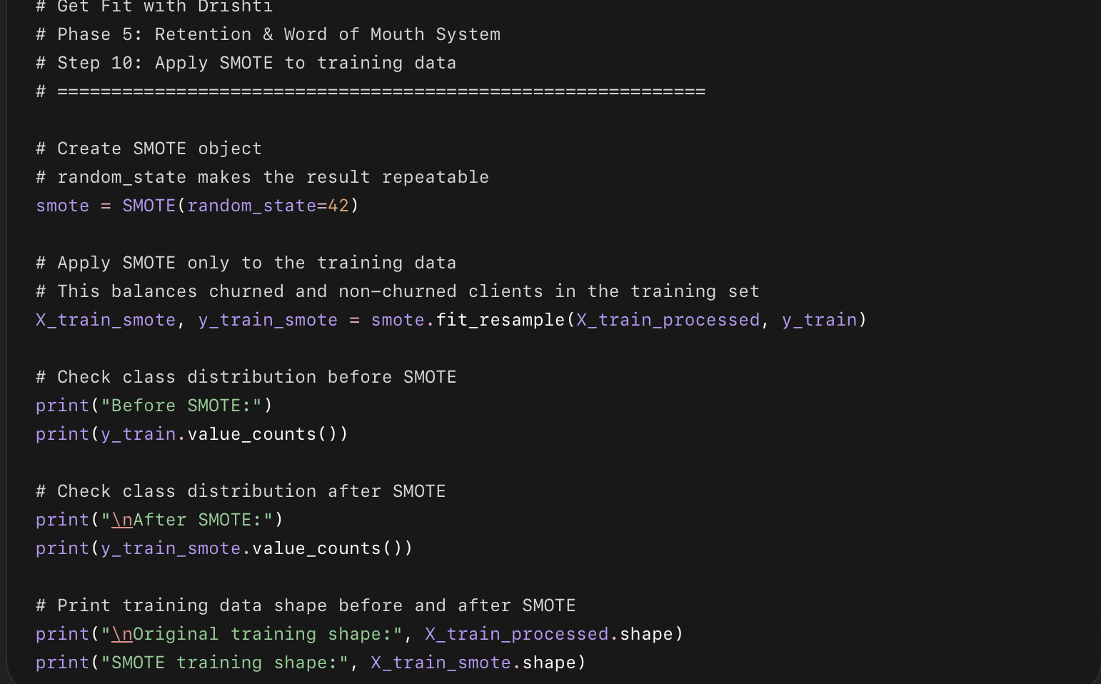

What this code does in easy points
- Creates a SMOTE object.
- Looks at the original training data imbalance.
- Creates synthetic churned-client examples.
- Balances the training dataset.
- Keeps testing data untouched.
- Creates two new variables:
  - X_train_smote
  - y_train_smote

Why we did this step
- Your dataset is imbalanced.
- Most clients completed the program.
- Fewer clients churned.
- Without fixing this, the model may become lazy and mostly predict:
Completed
- That would give high accuracy but poor churn detection.
- For this project, we care about finding clients who may drop out early.

What is SMOTE?
- SMOTE means Synthetic Minority Oversampling Technique.
- It creates new artificial examples of the smaller class.
- In our case, the smaller class is:
Churned clients
- It does not just copy existing churned clients.
- It creates similar new churn examples based on real churned clients.

Why we use SMOTE
- To help the model learn churn patterns better.
- To stop the model from ignoring churned clients.
- To make churned and non-churned clients balanced in the training data.
- To improve the model’s ability to catch at-risk clients early.

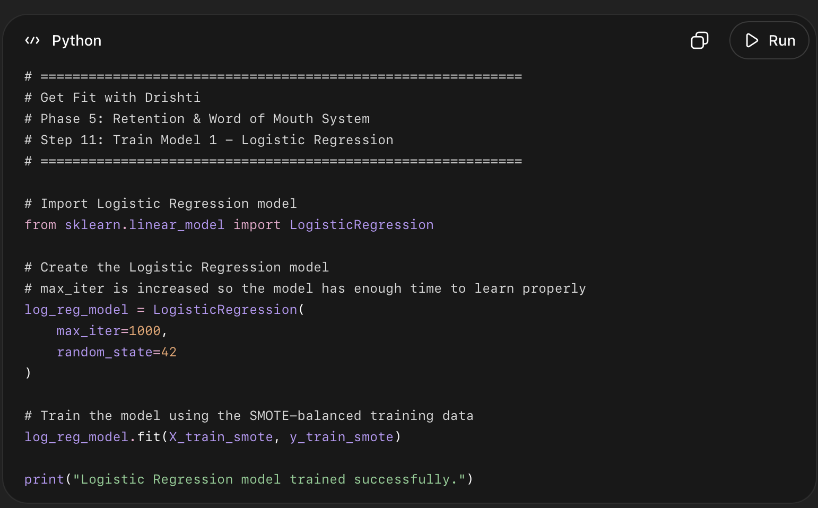

What this code does in easy points
- Imports the Logistic Regression model.
- Creates a model called log_reg_model.
- Trains it using the SMOTE-balanced training data.
- The model learns patterns between first-week client details and churn risk.
- This is our first churn prediction model.

Why Logistic Regression first?
- It is simple and easy to explain.
- It works well as a baseline model.
- It helps us understand which direction the project is going before using more advanced models.
- In business analytics, simple explainable models are often very valuable.
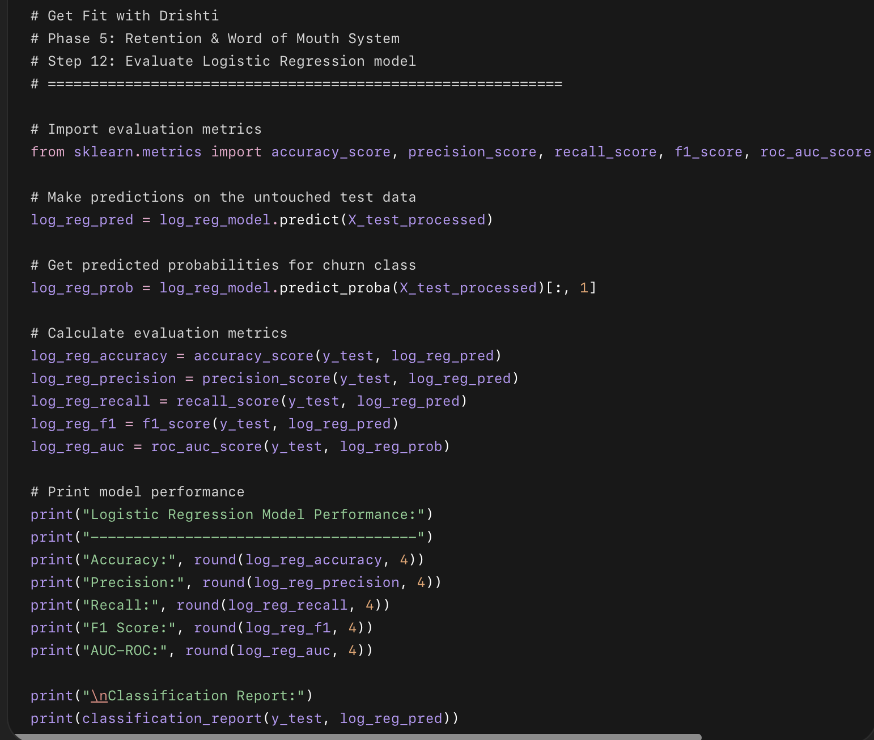

What this code does in easy points
- Uses the trained Logistic Regression model on the test data.
- Predicts whether each test client will churn or not.
- Calculates model performance using:
  - Accuracy
  - Precision
  - Recall
  - F1 Score
  - AUC-ROC
- Prints a detailed classification report.

What each metric means
- Accuracy: Overall, how many predictions were correct.
- Precision: Out of clients predicted as churn risk, how many actually churned.
- Recall: Out of actual churned clients, how many the model caught.
- F1 Score: Balance between precision and recall.
- AUC-ROC: How well the model separates churned vs non-churned clients.

Why recall matters most here
For this project, recall is very important.
Because Drishti wants to catch clients who may drop out early.
A missed churned client means:
The client may disappear before Drishti can help them.
It is better to flag a few extra clients than to miss the ones who really need support.

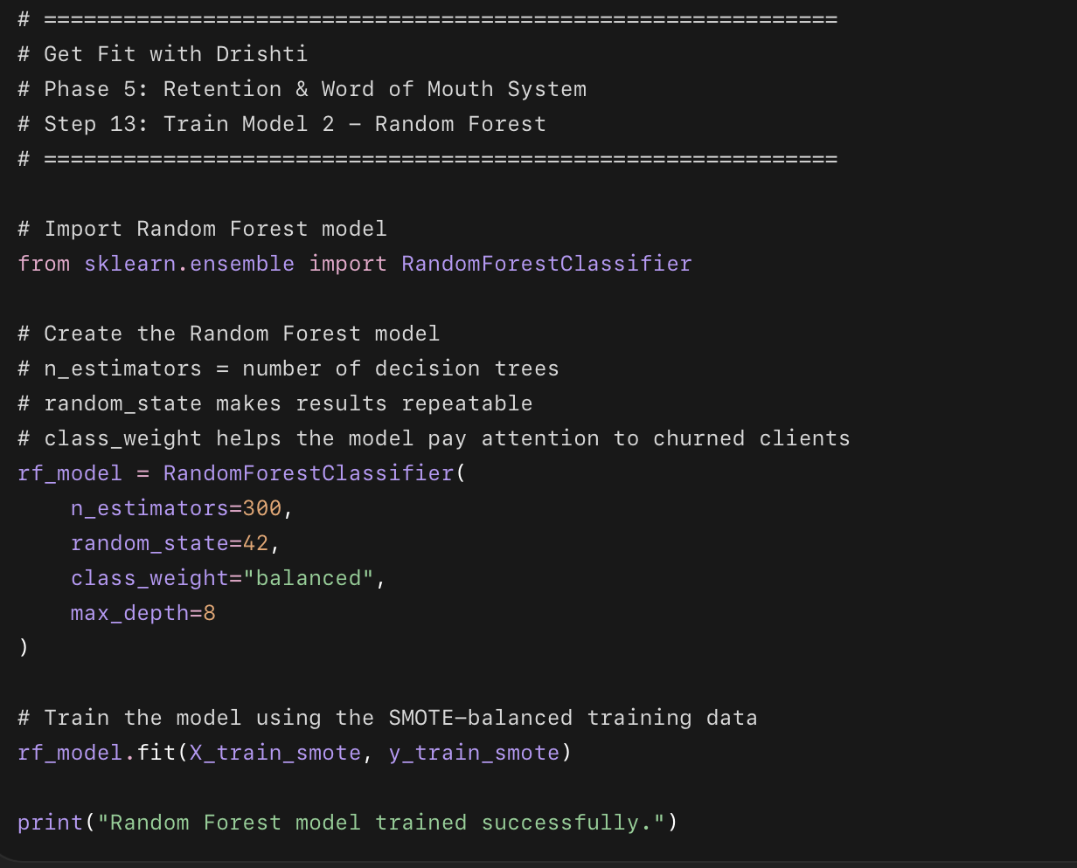

What this code does in easy points
- Imports the Random Forest model.
- Creates a model called rf_model.
- Uses many decision trees to learn churn patterns.
- Trains the model using the SMOTE-balanced training data.
- Uses class_weight="balanced" to keep churn detection important.
- Uses max_depth=8 so the trees do not become too complicated.

Why Random Forest?
- It can capture more complex patterns than Logistic Regression.
- It works well with mixed business data.
- It can later show which features are most important.
- It is useful for explaining what signals may lead to churn.

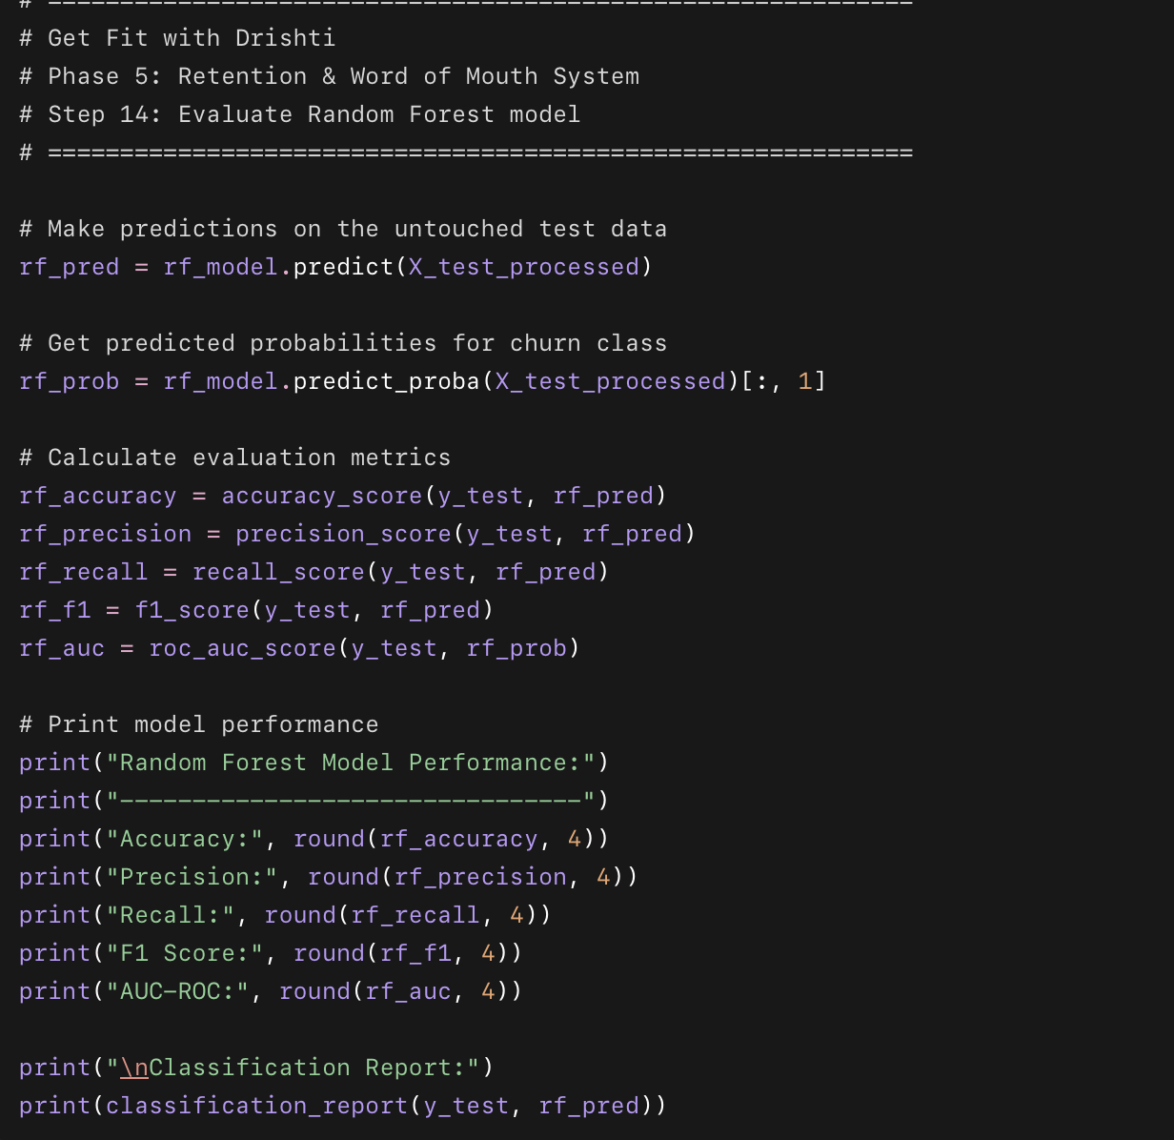

What this code does in easy points
- Uses the trained Random Forest model on the test data.
- Predicts which clients may churn.
- Calculates:
  - accuracy
  - precision
  - recall
  - F1 score
  - AUC-ROC
- Prints a classification report for completed and churned clients.

Why this step matters
We need to compare Random Forest against Logistic Regression.
Logistic Regression was our simple baseline. Random Forest may perform better because it can learn more complex patterns in the client data.
For Drishti’s business, this matters because:
Logistic Regression catches more at-risk clients.
Random Forest is more accurate when it does flag someone.
Since this project is about early intervention, we still care heavily about recall.

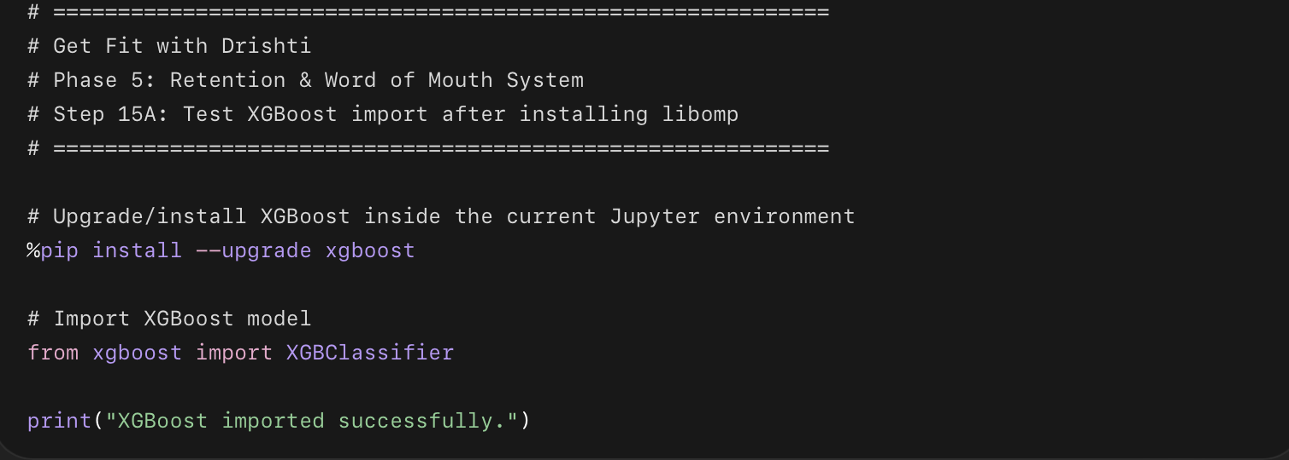

What this code does in easy points
- Makes sure XGBoost is installed in your current Jupyter environment.
- Imports XGBClassifier.
- Confirms that the Mac libomp issue is fixed.
- If this works, we can train XGBoost as Model 3.
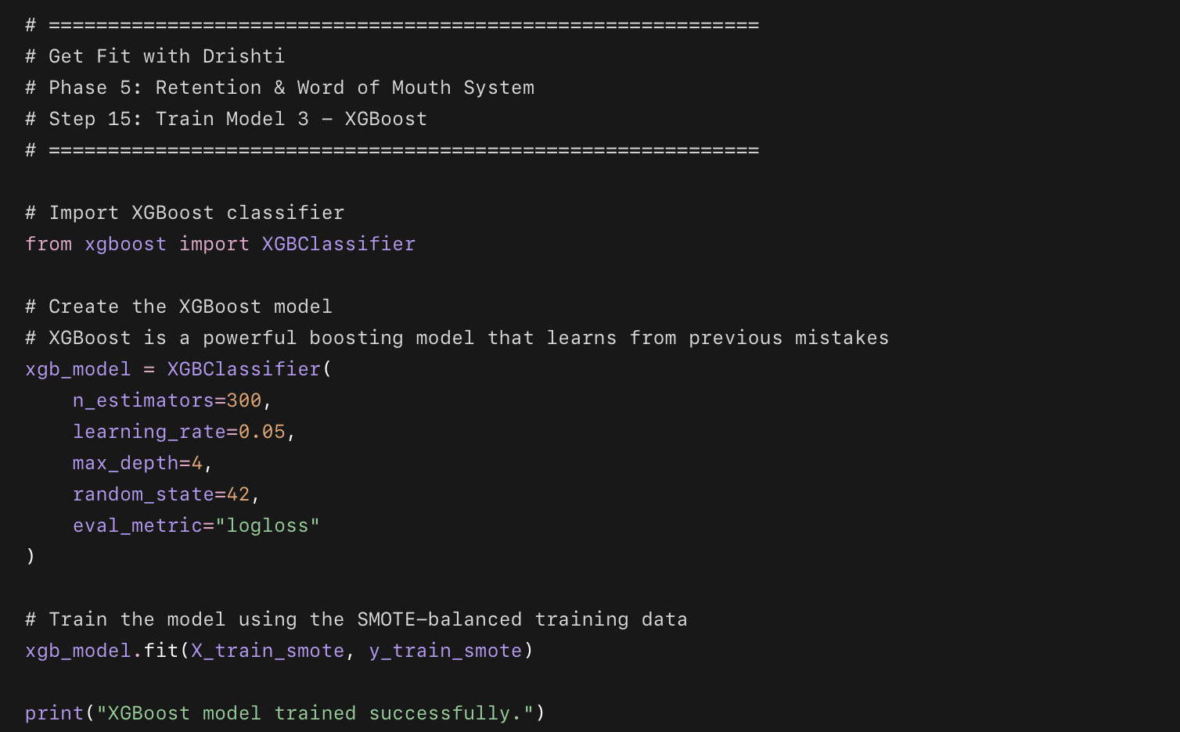

What this code does in easy points
- Imports the XGBoost model.
- Creates a model called xgb_model.
- Uses 300 boosting rounds/trees.
- Uses a learning rate of 0.05 so the model learns slowly and carefully.
- Uses max_depth=4 to control how complex each tree can become.
- Trains the model using the SMOTE-balanced training data.
- Saves the trained model for evaluation in the next step.

Why XGBoost is useful here
- It is strong for prediction problems like churn.
- It learns step by step.
- Each new tree tries to fix mistakes from earlier trees.
- It can capture complex patterns in client behavior.
- It is often stronger than basic Logistic Regression and Random Forest.
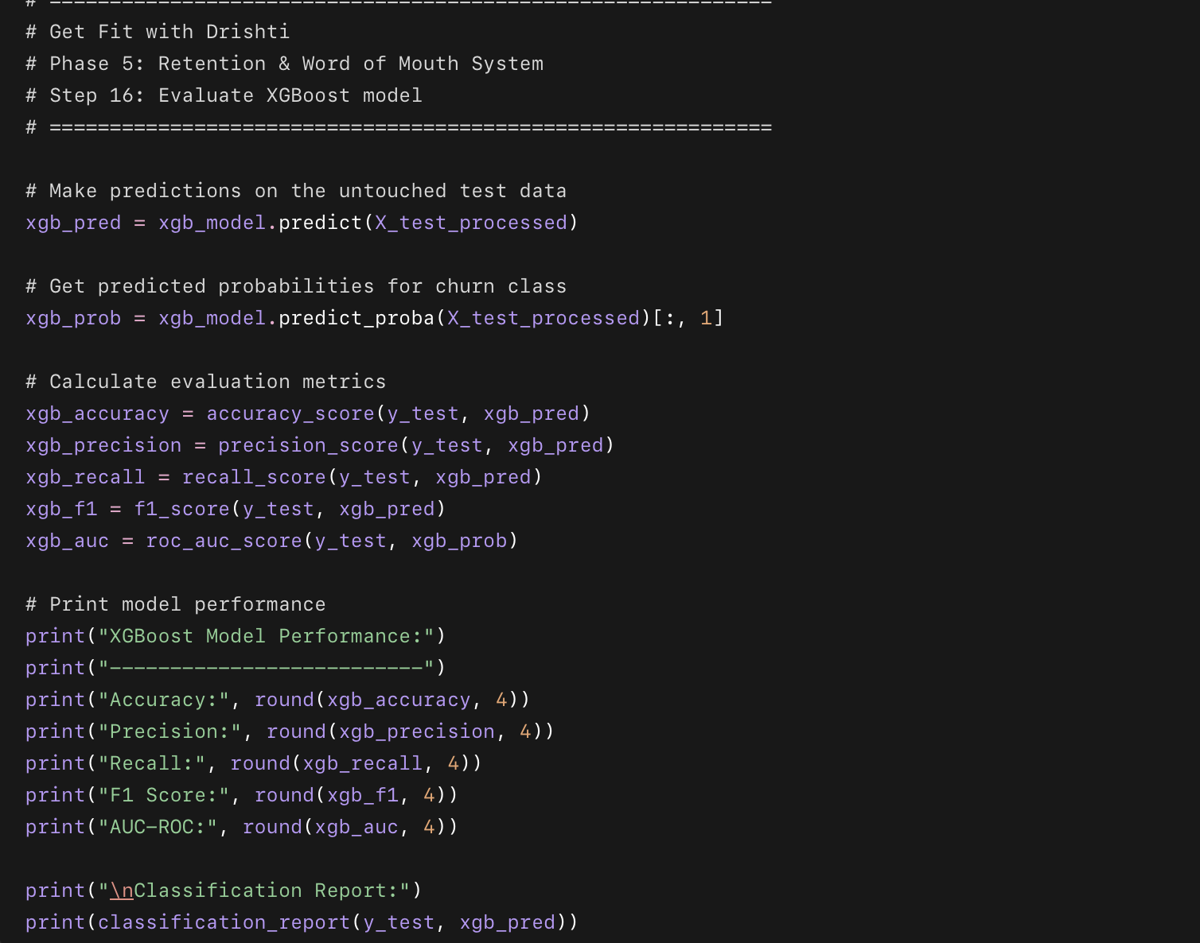

What this code does in easy points
- Uses the trained XGBoost model on the test data.
- Predicts which clients may churn.
- Calculates:
  - accuracy
  - precision
  - recall
  - F1 score
  - AUC-ROC
- Prints the classification report.
- This lets us compare XGBoost with Logistic Regression and Random Forest.
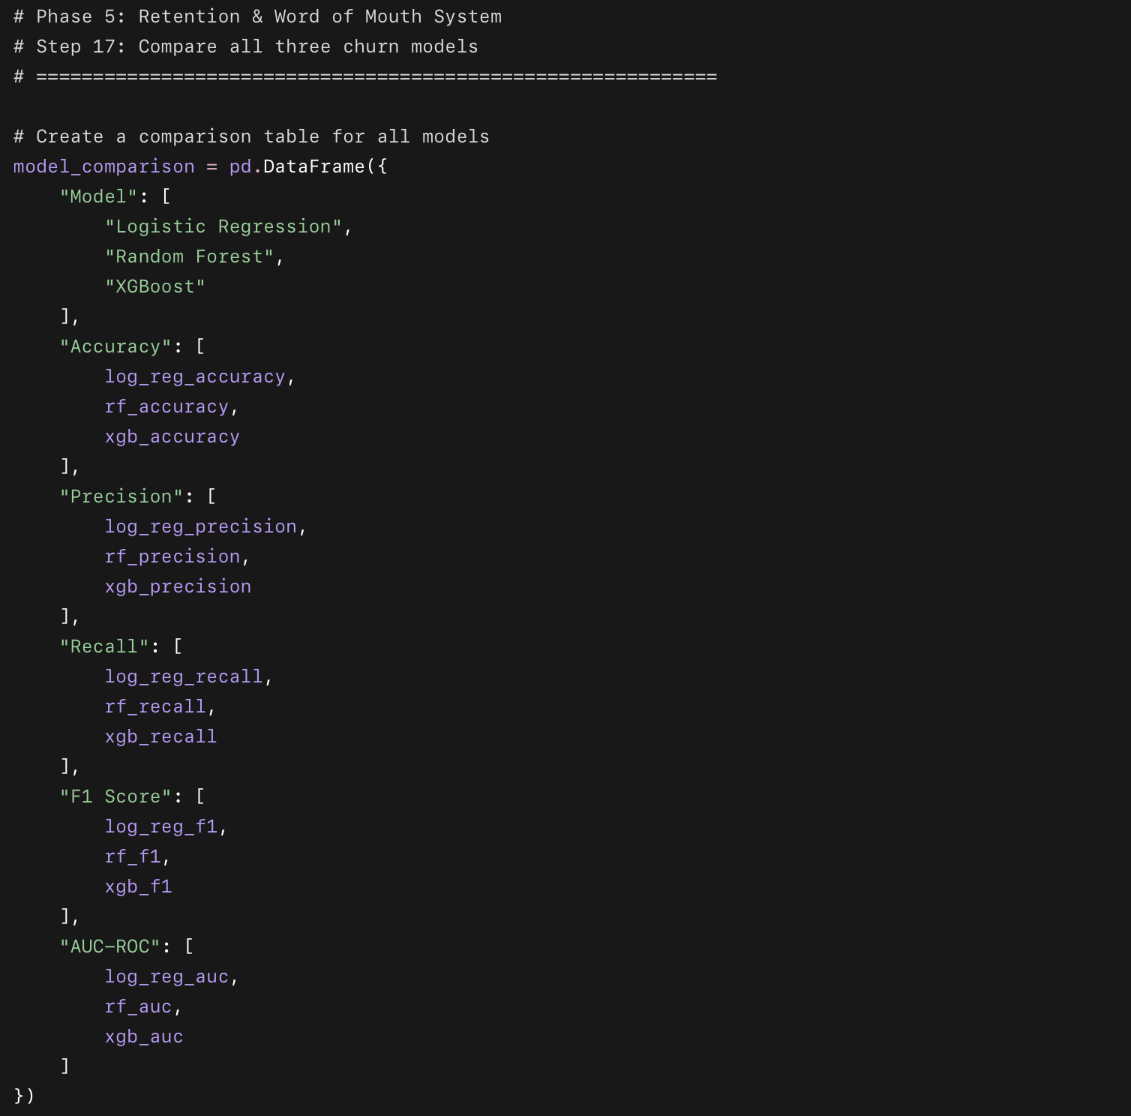
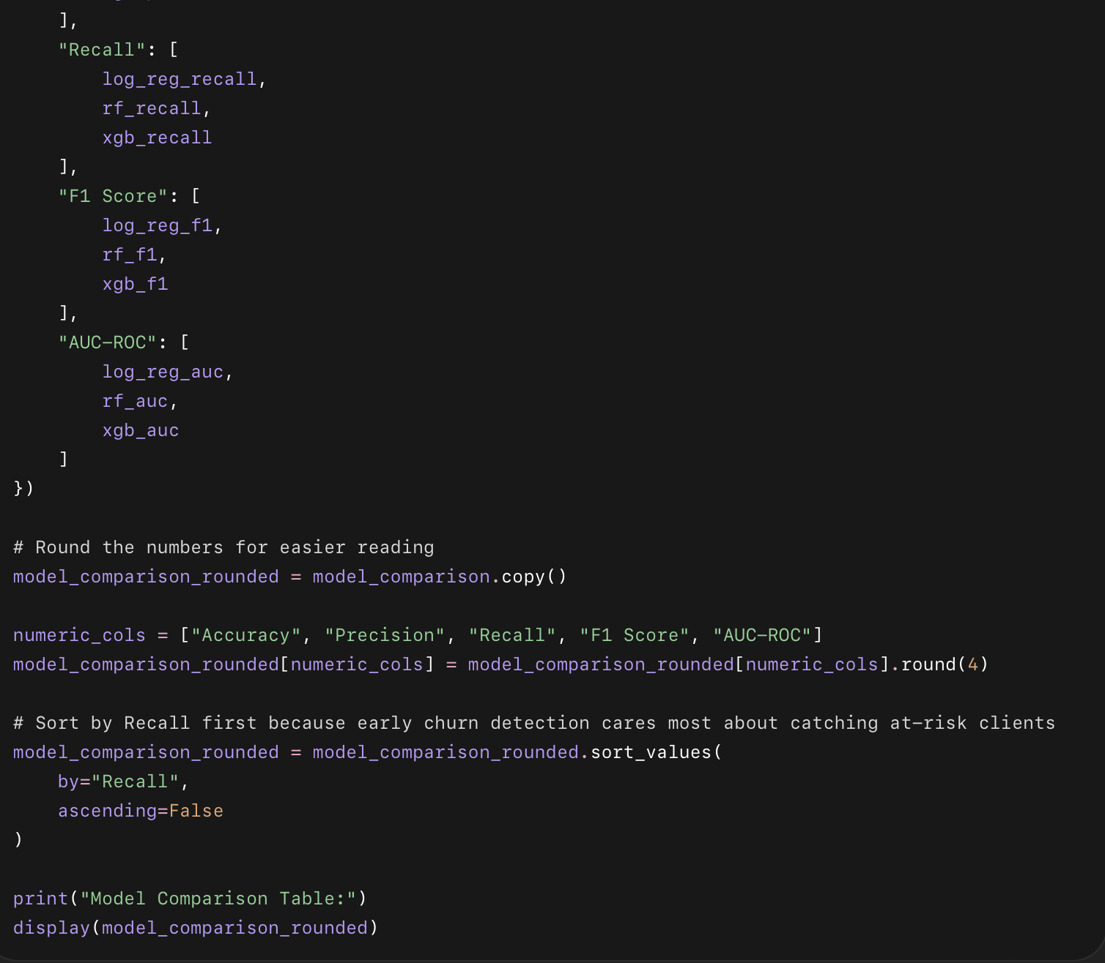

What this code does in easy points
- Creates one table comparing all three models.
- Includes:
  - Accuracy
  - Precision
  - Recall
  - F1 Score
  - AUC-ROC
- Rounds the numbers to make the table clean.
- Sorts the table by Recall because recall matters most for this early warning system.
- Helps us decide which model is most useful for Drishti.

Why we sort by Recall
For this project, the main goal is:
Find clients who may drop out early.
So recall matters most because it tells us:
Out of all clients who actually churned, how many did the model catch?
A model with high precision but low recall may look clean, but it can miss too many clients who need help.
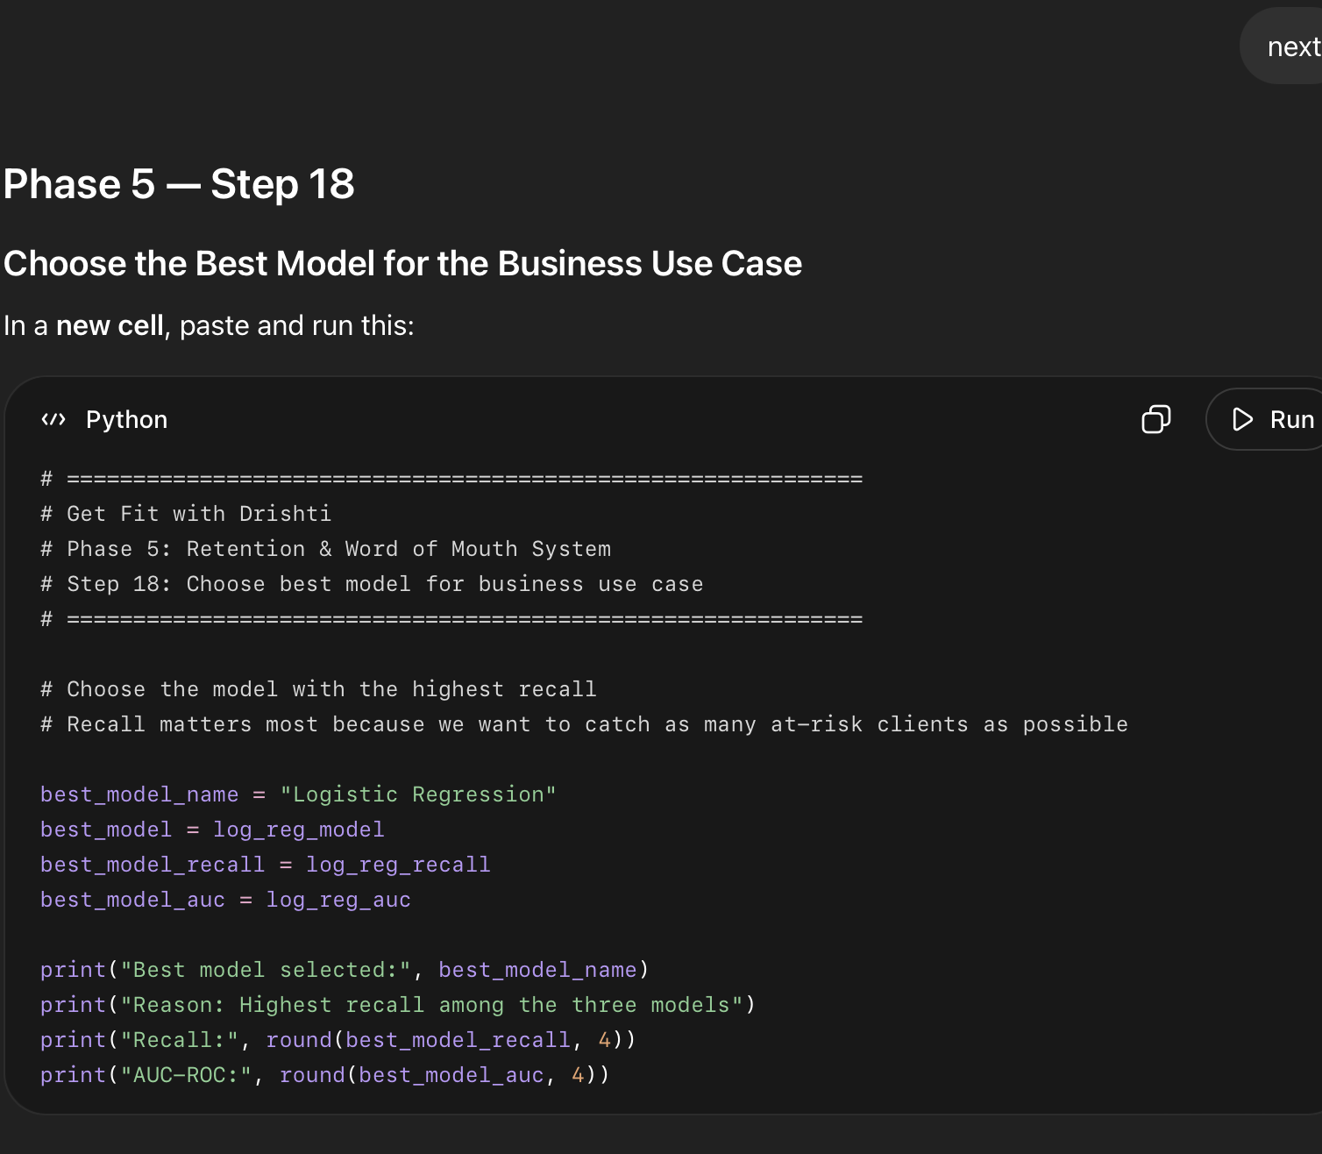

What this code does in easy points
- Selects Logistic Regression as the best model.
- Saves it as best_model.
- Stores the model name as best_model_name.
- Stores its recall and AUC-ROC.
- Explains why this model was selected.

Why we choose Logistic Regression
We are choosing Logistic Regression because it has the highest recall:
Logistic Regression recall = 57.89%
Random Forest recall = 42.11%
XGBoost recall = 37.72%
For this business problem, recall matters most because Drishti wants to catch clients before they disappear.
A false alarm is not a big problem because the action is simple:
send a supportive message
do an extra check-in
send a reminder
send a voice note
But missing a real at-risk client is a bigger problem.
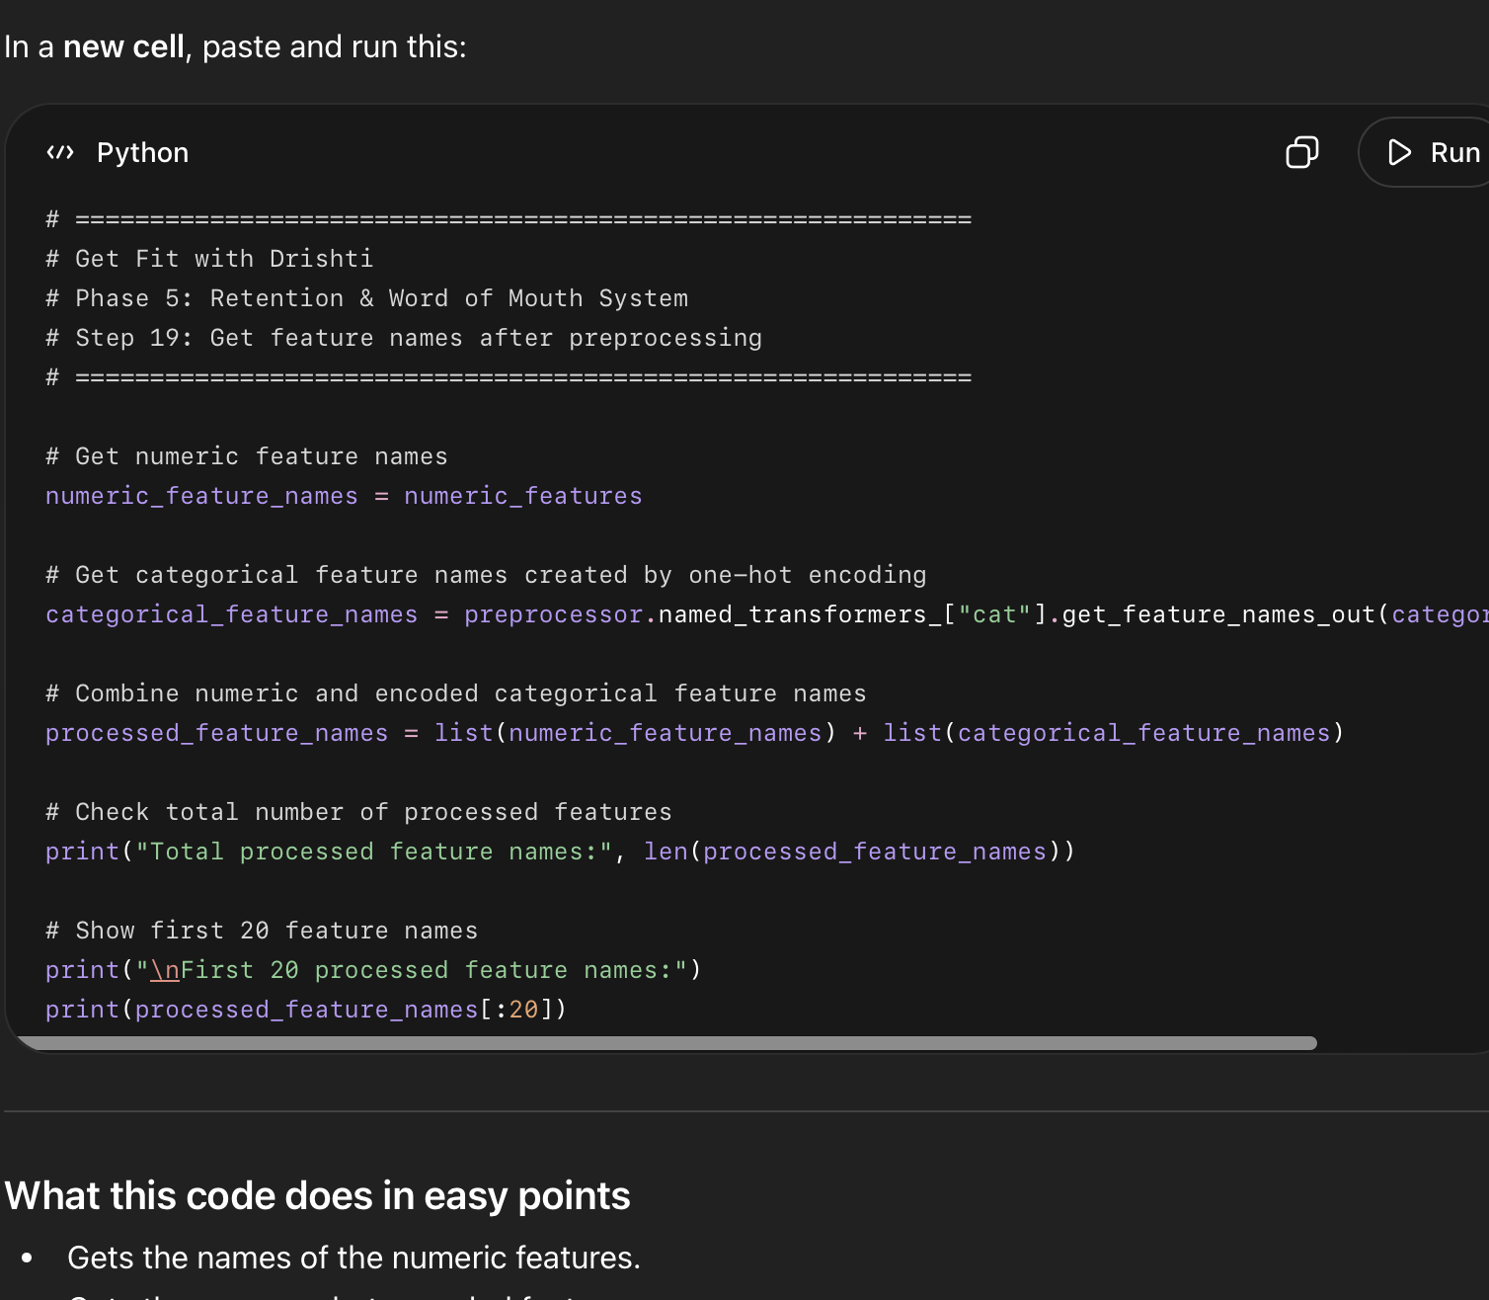

What this code does in easy points
- Gets the names of the numeric features.
- Gets the new one-hot encoded feature names.
- Combines everything into one list.
- Creates a list called:
processed_feature_names
- This helps us understand which processed columns are important to the model.

Why this step matters
Earlier, our 15 original columns became 44 processed columns.
Now we need the names of those 44 columns so we can explain the model properly.
This will help us answer:
What are the strongest churn signals?
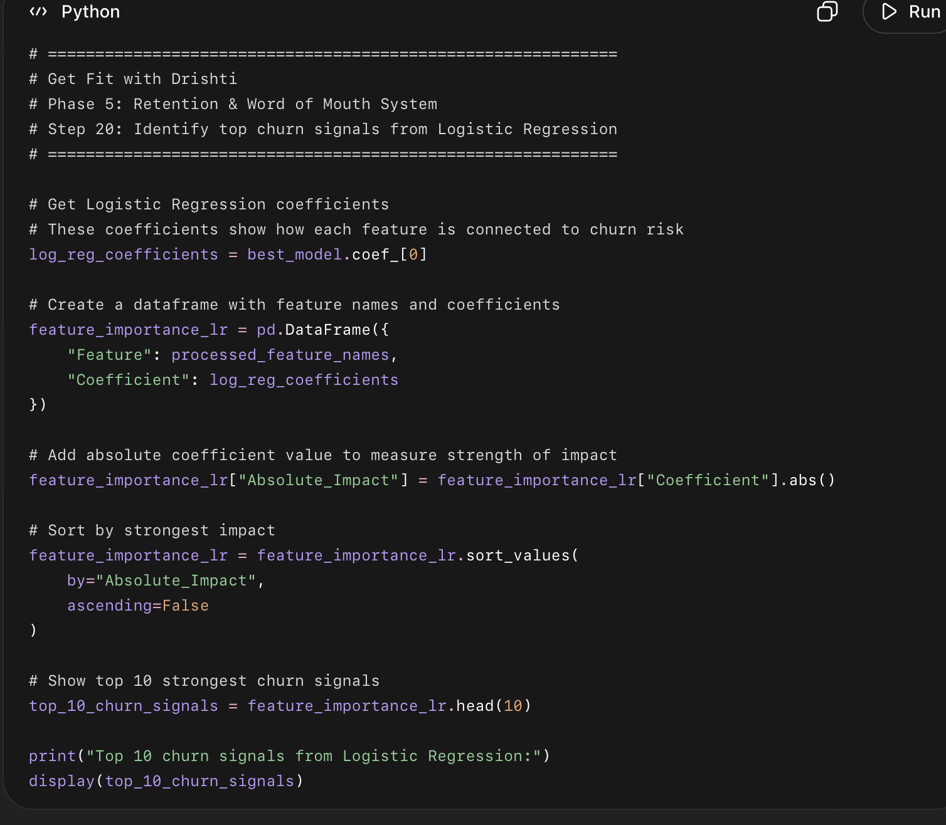

What this code does in easy points
- Pulls the coefficients from the selected Logistic Regression model.
- Connects each coefficient to its real feature name.
- Measures how strongly each feature affects churn prediction.
- Sorts the features by strongest impact.
- Shows the top 10 strongest churn signals.

How to read the coefficient
- A positive coefficient means the feature increases churn risk.
- A negative coefficient means the feature lowers churn risk.
- Bigger absolute value means stronger impact.
- Example:
  - Days_To_First_Engagement positive = slower engagement increases churn risk.
  - Ever_Engaged_Yes negative = clients who engage are less likely to churn.
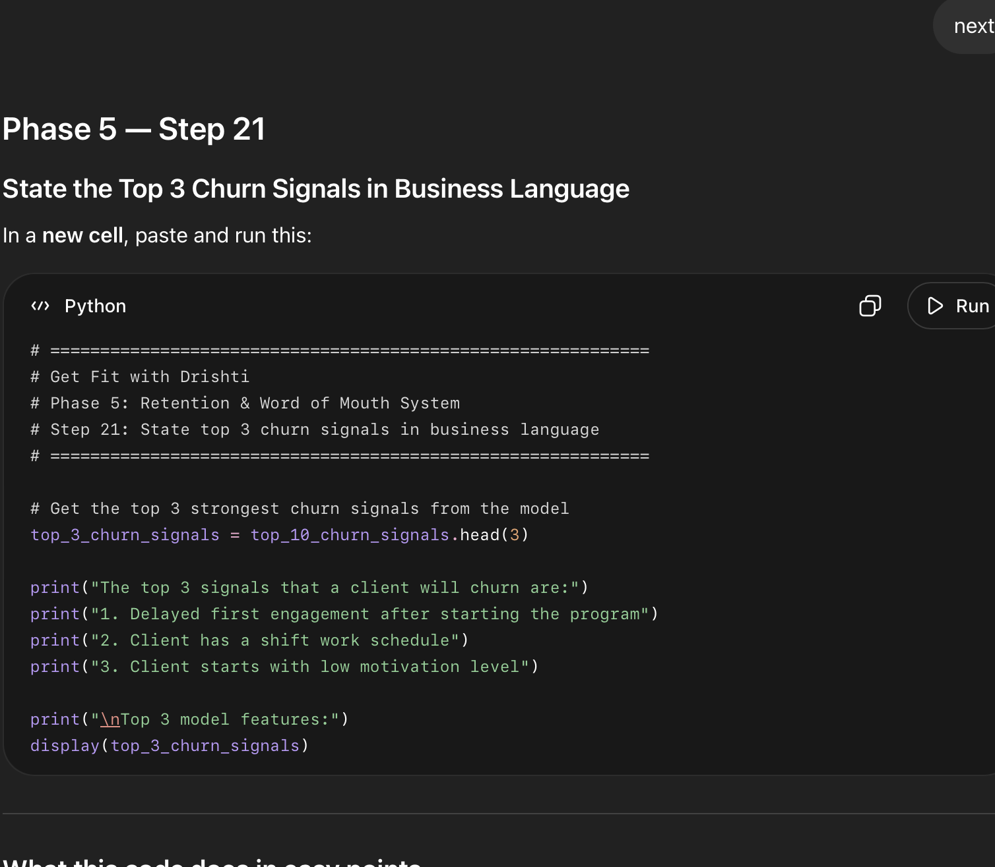

What this code does in easy points
- Takes the top 3 churn signals from the model.
- Converts them into simple business language.
- Shows the actual model features behind the interpretation.
- Gives you a clean statement you can use in your report and portfolio.
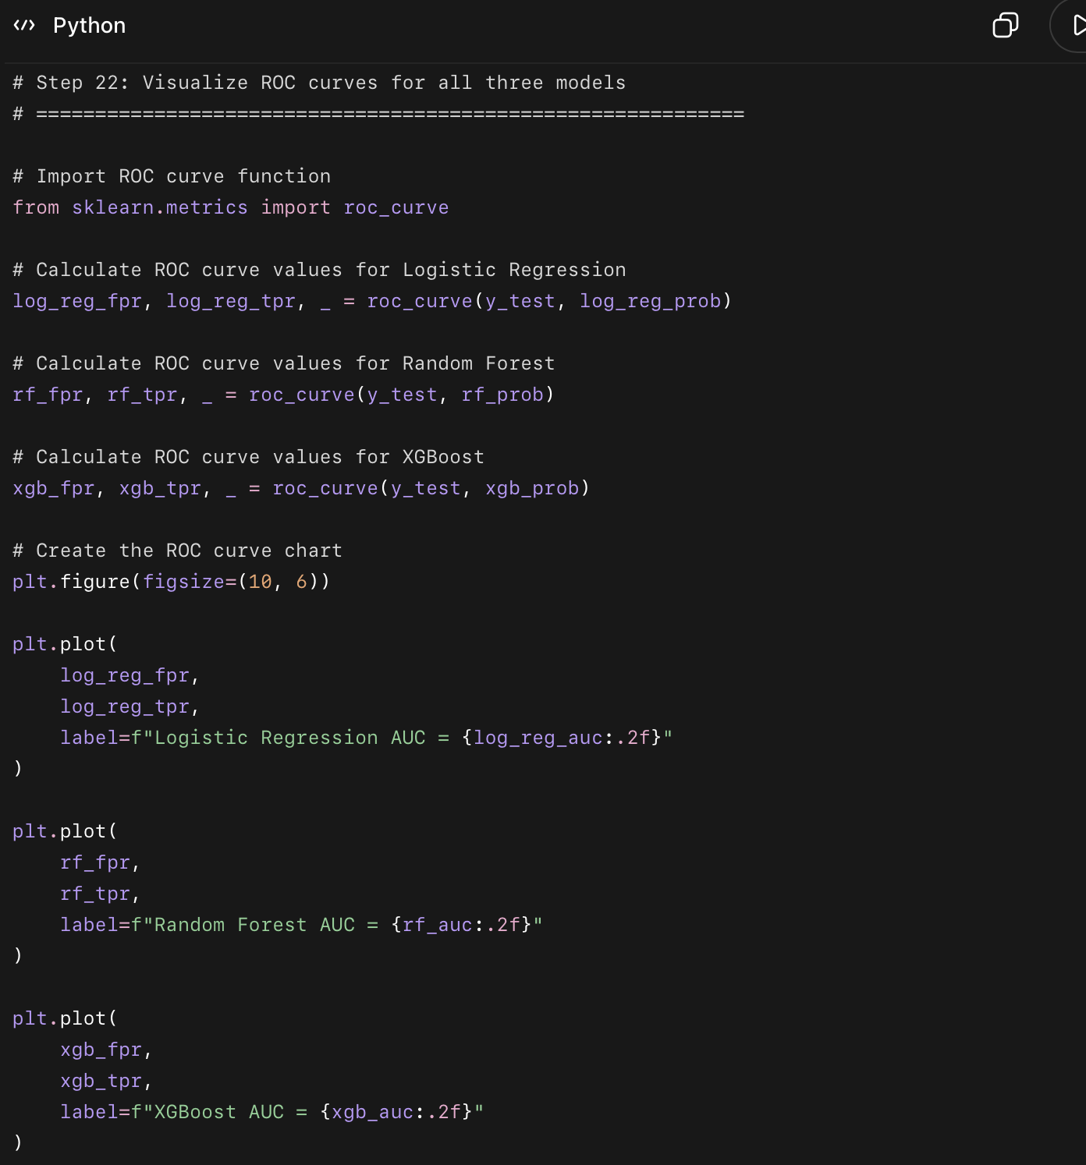
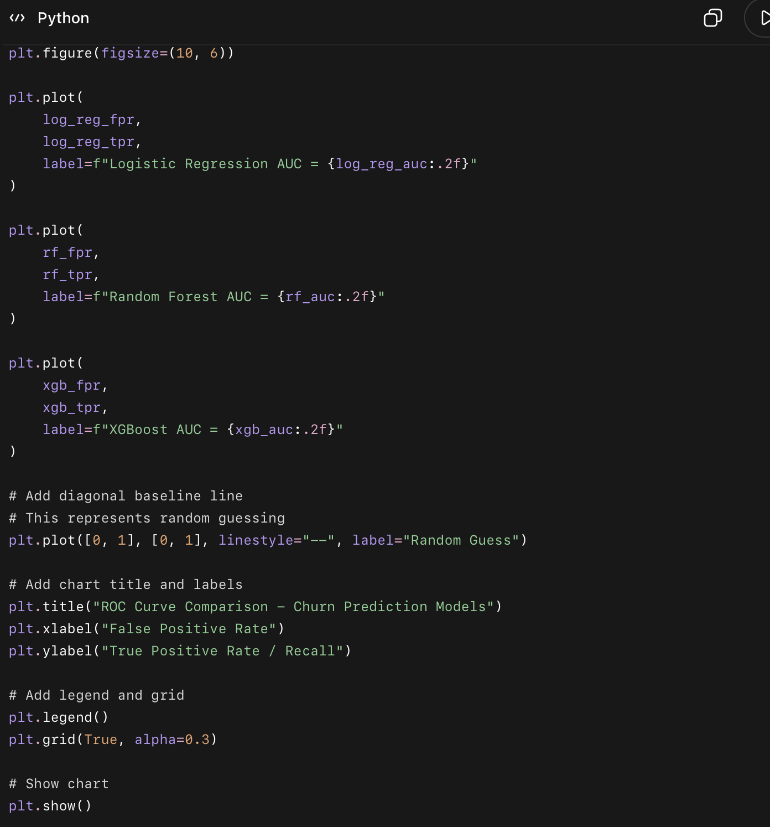

What this code does in easy points
- Creates ROC curves for all three models.
- Compares Logistic Regression, Random Forest, and XGBoost visually.
- Shows how well each model separates churned clients from completed clients.
- Adds AUC score for each model in the legend.
- Adds a random guessing line for comparison.

How to read this chart
- The higher the curve goes toward the top-left, the better.
- AUC closer to 1.0 is better.
- AUC around 0.5 means the model is close to random guessing.
- Random Forest and XGBoost should look stronger overall by AUC.
- Logistic Regression is still useful because it had the highest recall.

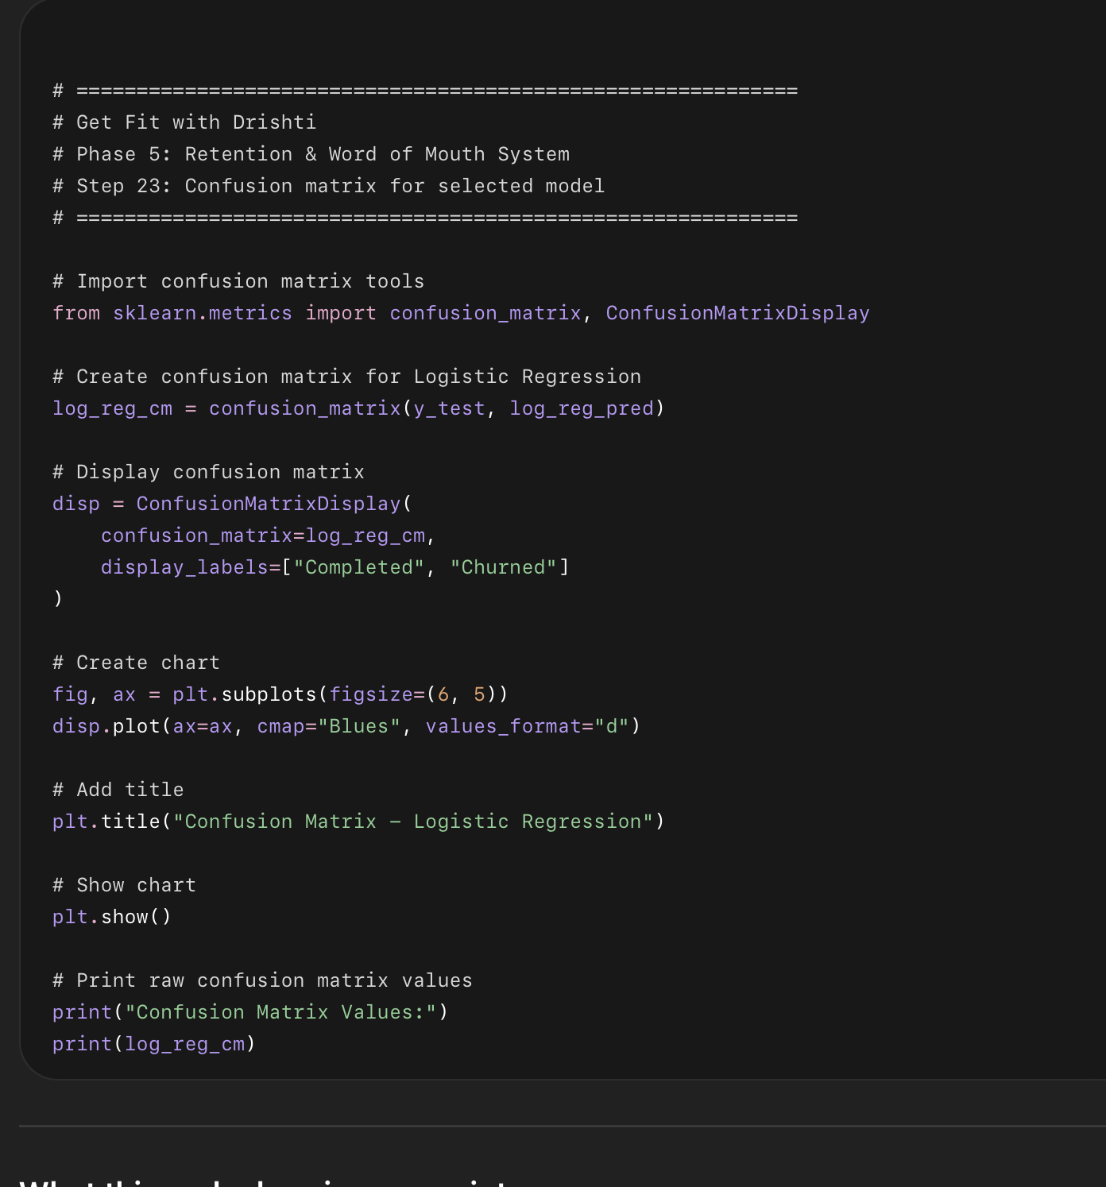

What this code does in easy points
- Creates a confusion matrix for the selected Logistic Regression model.
- Shows how many clients were predicted correctly and incorrectly.
- Breaks predictions into:
  - Completed predicted correctly
  - Completed wrongly flagged as churn risk
  - Churned missed by the model
  - Churned correctly caught by the model
- Displays the result as a chart.

How to read the confusion matrix
The chart will show 4 boxes:
Top-left: Completed clients correctly predicted as completed
Top-right: Completed clients wrongly predicted as churned
Bottom-left: Churned clients wrongly predicted as completed
Bottom-right: Churned clients correctly predicted as churned

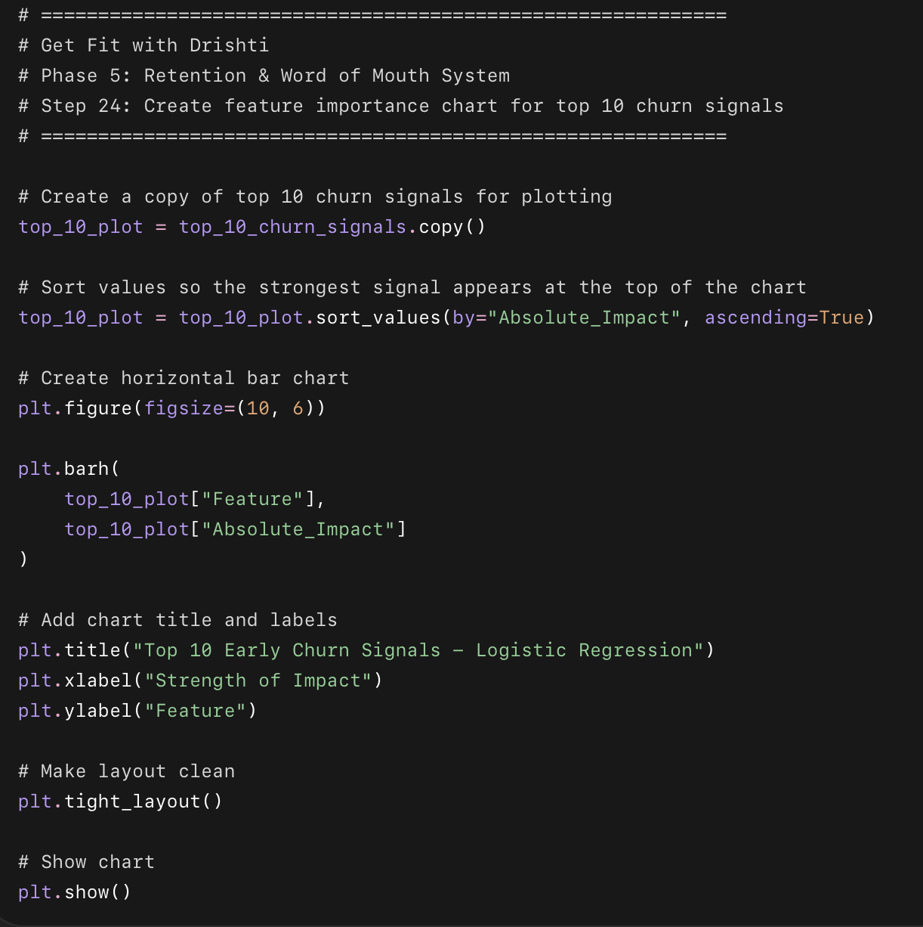

What this code does in easy points
- Uses the top 10 churn signals we already calculated.
- Creates a horizontal bar chart.
- Shows which features had the strongest impact on churn prediction.
- Uses Absolute_Impact, so both positive and negative signals can be compared by strength.
- Makes the strongest churn-related signals easy to explain visually.

Important note
This chart shows strength of impact, not direction.
So it tells us which features matter most, but not whether they increase or reduce churn.
For direction, we use the coefficient table:
Positive coefficient = increases churn risk
Negative coefficient = reduces churn risk
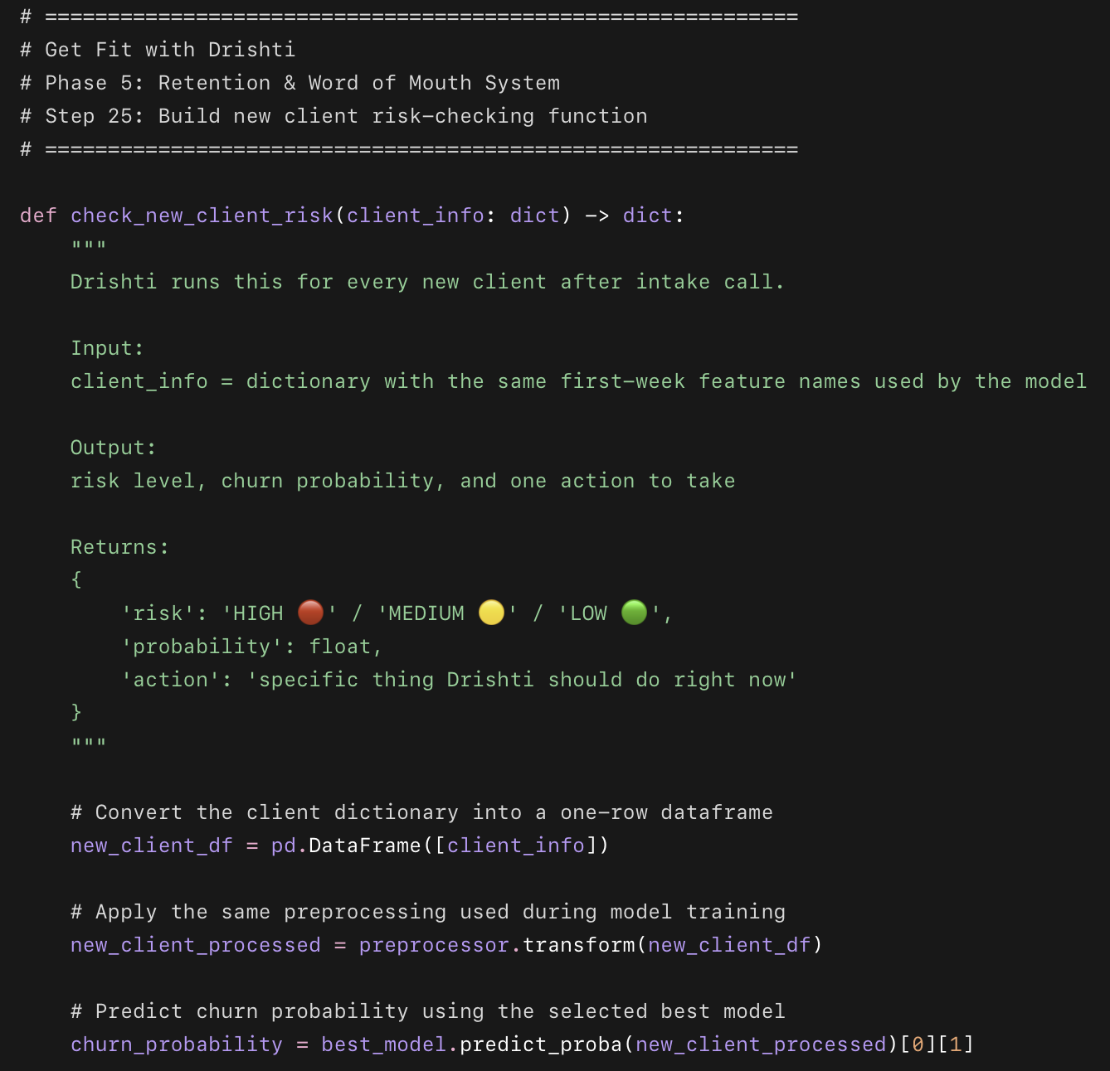
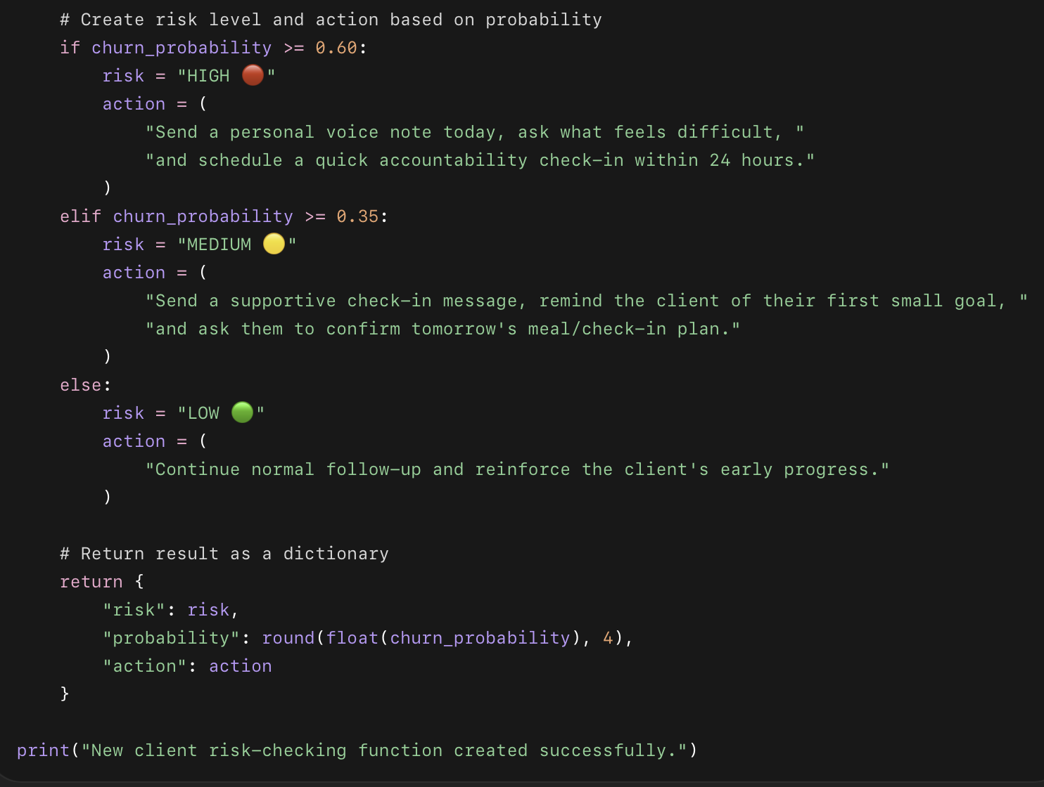

What this code does in easy points
- Creates a function called check_new_client_risk.
- Takes one new client’s information as a dictionary.
- Converts that client into a dataframe.
- Applies the same preprocessing used during training.
- Uses the selected Logistic Regression model.
- Predicts the client’s churn probability.
- Converts the probability into:
  - HIGH risk
  - MEDIUM risk
  - LOW risk
- Gives Drishti one specific action to take immediately.

Risk level logic
High Risk: probability 0.60 or above
Medium Risk: probability 0.35 to 0.59
Low Risk: below 0.35
These thresholds are practical business rules, not magic numbers. They help Drishti decide who needs urgent attention first.
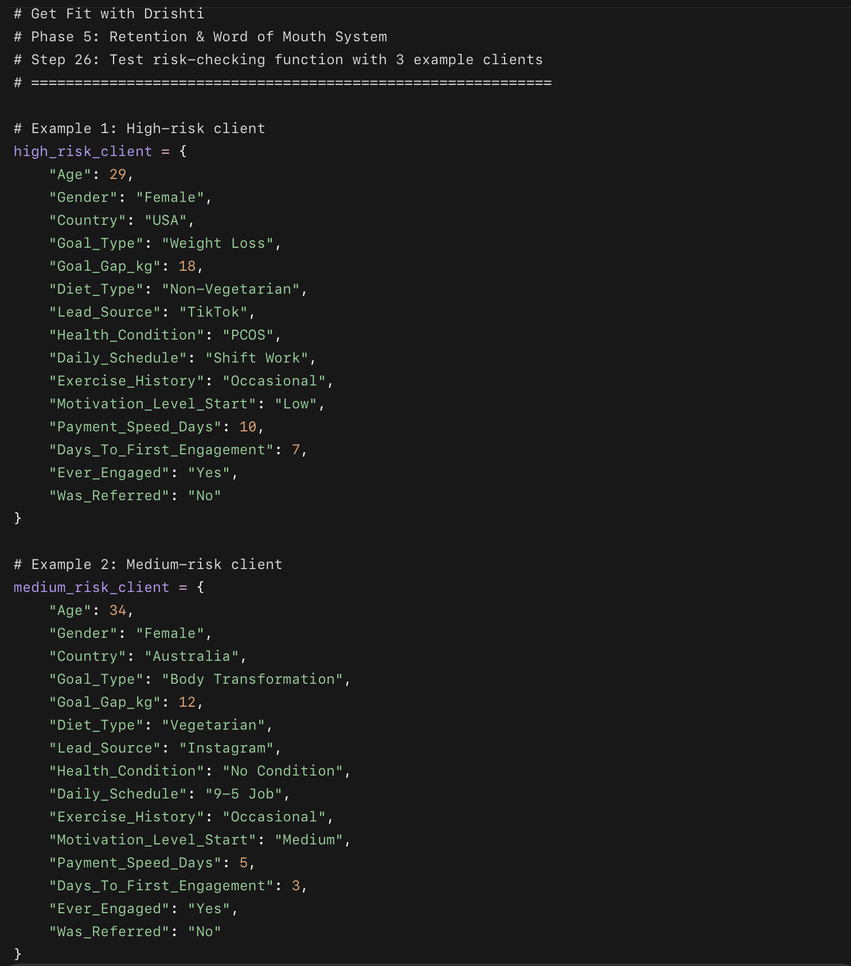
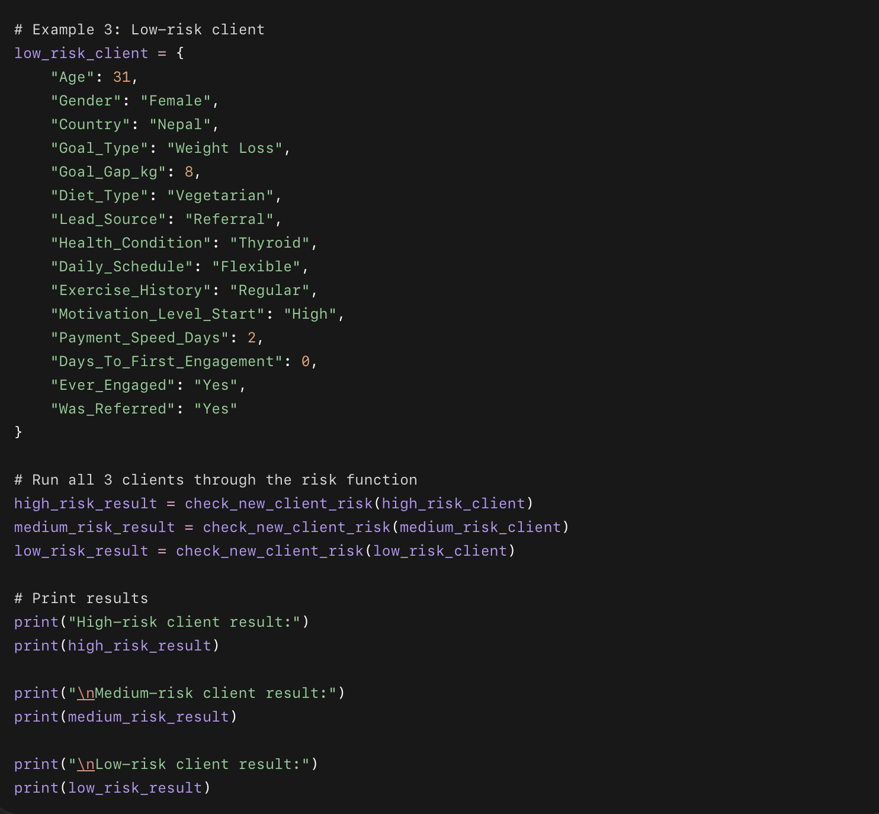

What this code does in easy points
- Creates 3 fake example clients.
- Each client has the same 15 features used by the model.
- Sends each client into the risk-checking function.
- Returns:
  - risk level
  - churn probability
  - action Drishti should take
- Proves that the model can be used like a real weekly business tool.

What you should see
You should get three outputs like this:
High-risk client result:
{'risk': 'HIGH 🔴', 'probability': ..., 'action': '...'}
Medium-risk client result:
{'risk': 'MEDIUM 🟡', 'probability': ..., 'action': '...'}
Low-risk client result:
{'risk': 'LOW 🟢', 'probability': ..., 'action': '...'}
The exact probabilities may be different, and that is okay.
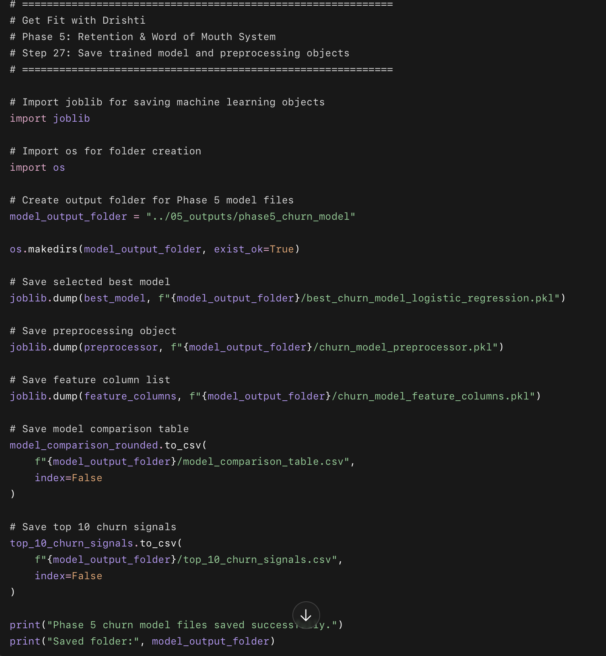

What this code does in easy points
- Creates a folder for Phase 5 churn model outputs.
- Saves the selected Logistic Regression model.
- Saves the preprocessing pipeline.
- Saves the list of model feature columns.
- Saves the model comparison table as a CSV.
- Saves the top 10 churn signals as a CSV.
- This lets you reuse the model later without rebuilding everything.

Why this step matters
This makes your project more professional.
Instead of only having notebook results, you now have actual saved model files and business output files.
These files can later be used for:
Dashboard
Weekly risk scoring
Portfolio project files
Final report
Future automation

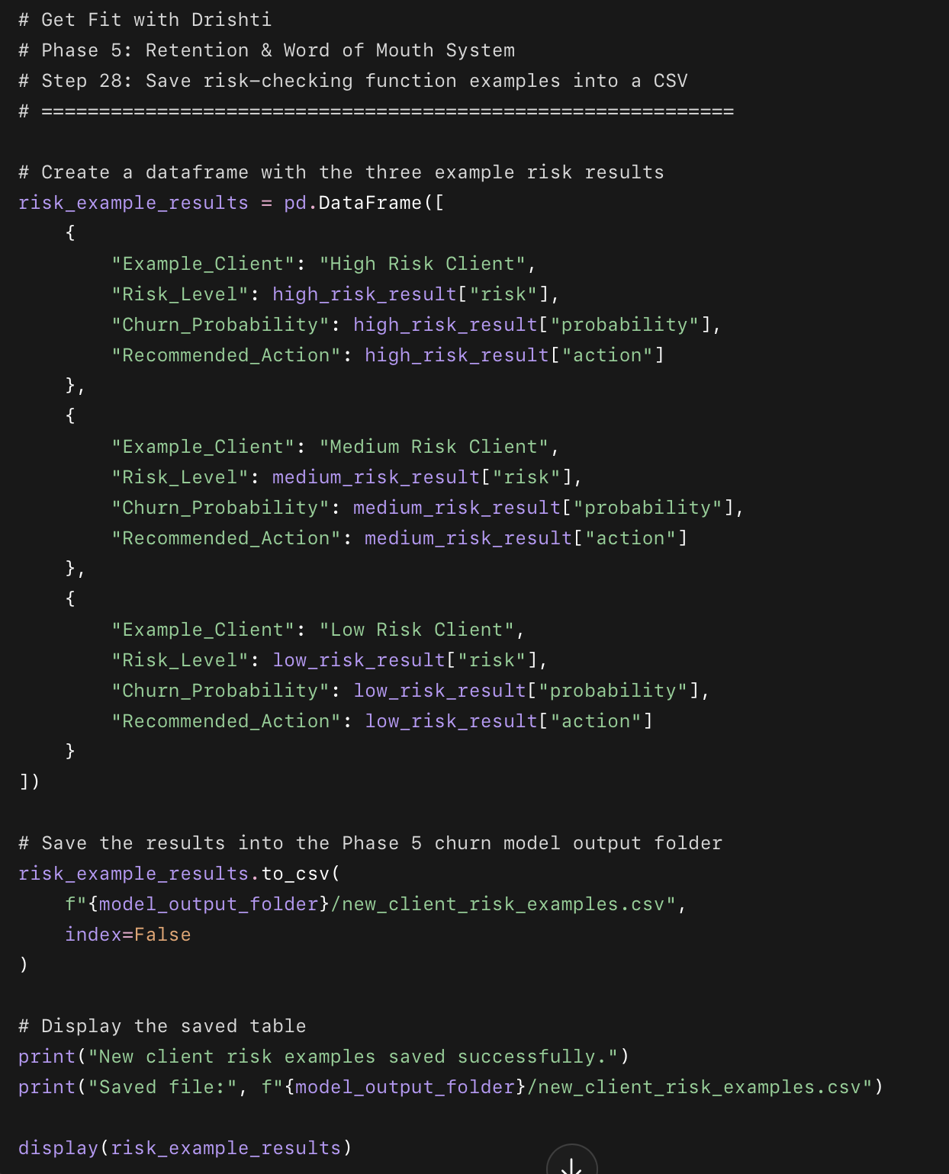

What this code does in easy points
- Creates a table from the 3 example clients.
- Saves their risk level, churn probability, and recommended action.
- Stores the table as a CSV file.
- Saves it inside your Phase 5 churn model folder.
- Displays the table so you can review it.

Why this step matters
This gives you a clean output file that proves the churn model can be used like a real tool.
You can include this in:
Final report
Portfolio screenshots
Tableau dashboard
Business recommendation section

